DESIGN AND DEVELOPMENT OF AI DRIVEN E NOSE
SYSTEM FOR FOOD QUALITY ANALYSIS IN APPLE
A MAJOR PROJECT REPORT
Submitted by
KOTAPATI VENKATA SASI KIRAN REDDY
YERUVA MAHESWARAREDDY
YAKKANTI VENKATA SRI CHARAN REDDY
Under the Guidance of
Dr.E.D KANMANI RUBY
in partial fulfillment for the award of the degree
of
BACHELOR OF TECHNOLOGY
in
ELECTRONICS & COMMUNICATION ENGINEERING

MAY 2023
BONAFIDE CERTIFICATE
Certified that this major project report entitled ”DESIGN AND DEVELOPMENT OF AI DRIVEN E NOSE SYSTEM FOR FOOD QUALITY ANALYSYS IN APPLE FRUIT”is the bonafide work of KOTAPATI VENKATA SASI KIRAN REDDY (19UEEC0272),YERUVA
MAHESWARAREDDY (19UEEC0645) and YAKKANTI VENKATA SRI CHARAN
REDDY (19UEEC0630). who carried out this major project work.
SUPERVISOR HEAD OF THE DEPARTMENT
Dr.E.D KANMANI RUBY Dr.P.ESTHER RANI
Professor Professor
Department of ECE Department of ECE

Submitted for Evaluation of Major project held on:−−−−−−−−−−−−−−−−−−−−−−−−−−−−−−−−−−−−−−−−
Internal Examiner External Examiner ACKNOWLEDGEMENT
We express our deepest gratitude to our respected Founder Chancellor and President Col. Prof.Dr.R.Rangarajan,Foundress PresidentDr. R. Sagunthala Rangarajan, Chairperson Managing Trustee and Vice President.
We are very thankful to our beloved Vice Chancellor Prof. Dr. S. Salivahanan for providing us with an environment to complete the work successfully.
We obligated to our beloved Registrar Dr. E. Kannan for providing immense support in all our endeavours. We thankful to our esteemed Dean Academics Dr.A.T.Ravichandran for providing a wonderful environment to complete our work successfully.
We are extremely thankful and pay my gratitude to our Dean Dr. R.S. Valarmathi for her valuable guidance and support on completion of this project.
It is a great pleasure for us to acknowledge the assistance and contributions of our Head of the Department Dr. P. Esther Rani, Professor for her useful suggestions, which helped us in completing the work in time and we thank her for being instrumental in the completion of fourth year with her encouragement and unwavering support during the entire course.
We extremely thankful and pay our gratitude to our Major Project Guide Dr. E.D. KANMANI RUBY, Professor for her valuable guidance and support on completing this major project report in pleasant form.
We thank our department faculty, supporting staffs and my parents for encouraging and supporting me throughout the study to complete this project.
KOTAPATI VENKATA SASI KIRAN REDDY
YERUVA MAHESWARAREDDY
YAKKANTI VENKATA SRI CHARAN REDDY
TABLE OF CONTENTS
CONTENTS PAGE No.
ABSTRACT vi
LIST OF FIGURES vii
1 INTRODUCTION 1
1.1 Detection Of Food Spoilage 1
1.2 Overview of E-nose technology 2
1.3 Importance of food quality analysis 3
1.4 Application of e-nose technology in food quality analysis 4
1.5 AI-driven e-nose system for food quality analysis in apple fruit 5
1.6 Approaches Of Different Scientific Fields: 6
1.7 Potential Applications in the Food Industry 7
1.8 Flowchart of Authentication system 9
1.9 Features 10
1.9.1 Sensor Array 10
1.9.2 Machine Learning Algorithms 11
1.9.3 Data Analysis Software 13
1.9.4 Real time Monitoring 14
1.9.5 Wireless Connectivity 15
2 LITERATURE SURVEY 16
2.1 This chapter Explains about food spoilage and quality control 16
3 METHODOLOGY 22
3.1 PROPOSED SYSTEM 22
3.1.1 Python IDLE 23
3.1.2 Cloud 25
3.1.3 Roboflow for Annotation 27
3.1.4 Arduino IDE For Serial Communication 29
3.1.5 LCD (Liquid Crystal Display) 31
3.1.6 ARDUINO 34
3.1.7 LM 35 Sensor 36
3.1.8 Raspberry Pi 38
3.1.9 MQ Sensor 39
4 IMPLEMENTATION 42
5 RESULTS AND DISCUSSION 53
6 CONCLUSION 59
REFERENCES 59

ABSTRACT
Food spoilage is a significant problem in the food industry, causing significant economic losses and posing health risks to consumers. One common type of food spoilage is the decay of fresh fruits such as apples, which can be caused by a variety of factors, including microbial growth, physical damage, and exposure to oxygen. In this project, we propose the use of artificial intelligence (AI) to develop a system for the detection of fresh and rotten apples in the food industry. The system will use machine learning algorithms to analyse images of apples and classify them as fresh or rotten based on their visual appearance. The system will be developed using a dataset of images of apples, both fresh and rotten, that have been collected from different sources in the food industry. The model, which will learn to classify apples based on their visual features. After that depends on sensor based reading signals output decision will be taken.

LIST OF FIGURES
Sl.No. TITLE PAGE No.
1.1 Hardware block Diagram . . . . . . . . . . . . . . . . . . . . . . . . . . . . . . . . . . . | 9
1.2 Software block Diagram . . . . . . . . . . . . . . . . . . . . . . . . . . . . . . . . . . . | 10
3.1 Hardware Setup . . . . . . . . . . . . . . . . . . . . . . . . . . . . . . . . . . . . . . . | 31
3.2 LCD(Liquid Crystal Display) . . . . . . . . . . . . . . . . . . . . . . . . . . . . . . . . | 32
3.3 LCD . . . . . . . . . . . . . . . . . . . . . . . . . . . . . . . . . . . . . . . . . . . . . | 33
3.4 LCD pinout diagram . . . . . . . . . . . . . . . . . . . . . . . . . . . . . . . . . . . . | 34
3.5 ARDUINO UNO . . . . . . . . . . . . . . . . . . . . . . . . . . . . . . . . . . . . . . . | 35
3.6 LM 35 SENSOR . . . . . . . . . . . . . . . . . . . . . . . . . . . . . . . . . . . . . . . | 37
3.7 Raspberry Pi . . . . . . . . . . . . . . . . . . . . . . . . . . . . . . . . . . . . . . . . . | 39
3.8 MQ Sensor . . . . . . . . . . . . . . . . . . . . . . . . . . . . . . . . . . . . . . . . . . | 40
5.1 fruit detection . . . . . . . . . . . . . . . . . . . . . . . . . . . . . . . . . . . . . . . . . | 54
5.2 Fresh fruit detection . . . . . . . . . . . . . . . . . . . . . . . . . . . . . . . . . . . . . | 55
5.3 Storing days detection of fruit . . . . . . . . . . . . . . . . . . . . . . . . . . . . . . . . | 55
5.4 Chemical detection in fruit . . . . . . . . . . . . . . . . . . . . . . . . . . . . . . . . . | 56
5.5 Temperature and Gas detection in fruits . . . . . . . . . . . . . . . . . . . . . . . . . . | 56
5.6 Wax Detection . . . . . . . . . . . . . . . . . . . . . . . . . . . . . . . . . . . . . . . . | 57
5.7 fruit detection 2 . . . . . . . . . . . . . . . . . . . . . . . . . . . . . . . . . . . . . . . . | 57
5.8 Rotten fruit detection . . . . . . . . . . . . . . . . . . . . . . . . . . . . . . . . . . . . | 58
5.9 Storing Days detection For Fruit . . . . . . . . . . . . . . . . . . . . . . . . . . . . . . | 58

CHAPTER 1

INTRODUCTION

1.1 Detection Of Food Spoilage
Food spoilage is a common issue that occurs in the food industry, and it can cause significant economic losses. Additionally, food spoilage can result in food-borne illnesses, which can have serious health consequences. Therefore, detecting food spoilage is crucial to prevent economic losses and ensure food safety. In this essay, we will discuss the various methods used to detect food spoilage.Visual inspection is the simplest method to detect food spoilage. It involves looking for changes in color, texture, and odor. Visual inspection is subjective and can be affected by the individual’s experience and knowledge of the food product. Therefore, it is essential to have trained personnel to conduct visual inspections. Visual inspection is commonly used in the food industry to detect spoilage in fruits, vegetables, and meats.Chemical analysis involves testing. Most common method used in chemical analysis is pH measurement. Spoilage causes an increase in pH, which indicates the presence of bacteria. Additionally, chemical analysis can detect the presence of specific compounds that are produced during spoilage. For example, the presence of trimethylamine in fish indicates spoilage.
Microbiological analysis involves testing the food product for the presence of bacteria, yeast, and mold. This method is based on the fact that spoilage is caused by microorganisms. The most common method used in microbiological analysis is the plate count method, which involves counting the number of colony-forming units (CFUs) on a culture plate. A high CFU count indicates the presence of bacteria, yeast, or mold, which can cause spoilage.Electronic nose technology involves using a device that can detect. The device consists a sensor array can detect various VOCs. Each VOC produces a unique signal, which is used to identify the specific compound. Electronic nose technology is rapid and non-invasive, making it an ideal method for detecting food spoilage.Spectroscopy involves using light to analyze. Spectroscopy can detect chemical composition of a food product that are caused by spoilage. The most common method used in spectroscopy is infrared spectroscopy, which involves measuring the absorption of infrared light by the food product. Spectroscopy is a non-invasive method that can be used to analyze food products in their natural state. DNA-based methods involve detecting the DNA of microorganisms that cause spoilage. The most common method used in DNAbased methods is polymerase chain reaction (PCR), which amplifies the DNA of the microorganism. DNA-based methods are highly sensitive and specific, making them ideal for detecting low levels of microorganisms that cause spoilage.Detecting food spoilage is crucial to prevent economic losses and ensure food safety. The methods discussed in this essay, including visual inspection, chemical analysis, microbiological analysis, electronic nose technology, spectroscopy, and DNA-based methods, are commonly used in the food industry to detect food spoilage. Each advantages and disadvantages, various.Therefore, it is essential to have trained personnel and use a combination of methods to ensure the detection of food spoilage.

1.2 Overview of E-nose technology
Electronic nose is a device that mimics the sense of smell of a human or animal. It is used to detect and identify various odors and volatile organic compounds (VOCs) in a given environment. The technology of e-nose has been developed over the years and has various applications in different fields such as food and beverage, medical diagnosis, environmental monitoring, and chemical analysis.E-nose technology is based on the principle of chemosensors, which is a sensor that is sensitive to chemical changes in the environment. Chemosensors are designed to detect specific chemical compounds by reacting with them, and this reaction produces an electrical signal that can be measured and analyzed. E-nose technology utilizes various types of chemosensors, such as metal oxide sensors, quartz crystal microbalance sensors, and conducting polymer sensors.The metal oxide sensors are based on the principle of the change in resistance of metal oxide films when they are exposed to different gases. These sensors are commonly used in e-noses for detecting.The quartz crystal microbalance sensors are based on the principle of the change in mass of a crystal when it is exposed to different gases. These sensors are commonly used in e-noses for detecting volatile organic compounds, and they are highly sensitive and accurate.The conducting polymer sensors are based on the principle of the change in conductivity of a polymer film when it is exposed to different gases. These sensors are commonly used in e-noses for detecting gases such as ammonia, hydrogen, and carbon dioxide.E-nose technology has various applications in the food and beverage industry. It is used for quality control and assurance of food products, such as meat, dairy products, and wine. E-noses can detect the presence of spoilage or contamination in these products, which can help prevent the spread of diseases and foodborne illnesses. E-noses are also used to monitor the freshness of packaged foods and detect the presence of harmful substances such as pesticides and preservatives.
In the medical field, e-nose technology is used for diagnosis and monitoring of diseases such as asthma, lung cancer, and diabetes. E-noses can detect changes in the breath of patients, which can help doctors diagnose these diseases at an early stage. E-nose technology can also be used to monitor the effectiveness of treatment for these diseases.E-nose technology has also been used for environmental monitoring. It can be used to detect and monitor air pollution, water pollution, and soil contamination. E-noses can detect the presence of harmful chemicals and pollutants, which can help prevent the spread of diseases and protect the environment.E-nose technology has various advantages over traditional methods of detecting and analyzing odors and VOCs. E-noses are non-invasive, nondestructive, and can detect multiple odors simultaneously. They are also portable, cost-effective, and require minimal maintenance. E-noses can be used in a wide range of environments, such as hospitals, laboratories, and industrial settings.E-nose technology also has some limitations. E-noses have limited sensitivity and selectivity, and they can be affected by changes in temperature and humidity. E-noses also require calibration and validation, which can be time-consuming and require specialized knowledge.E-nose technology is a promising field that has various applications in different fields such as food and beverage, medical diagnosis, environmental monitoring, and chemical analysis. E-nose technology has various advantages over traditional methods of detecting and analyzing odors and VOCs, such as being non-invasive, non-destructive, and portable. However, e-noses also have some limitations, such as limited sensitivity and selectivity, and the need for calibration and validation.

1.3 Importance of food quality analysis
Food quality analysis is an essential component of the food industry. It involves evaluating the composition the raw materials to the finished products. The analysis provides an insight into the nutritional value, authenticity, and safety of food products. It is important to ensure that food products meet the required standards, as they have a significant impact on the health and wellbeing of consumers. This article explores the importance of food quality analysis in detail.Food quality analysis provides information on the nutritional value of food products. Nutritional information is critical for consumers to make informed decisions about their food choices. Analysis of food products provides information on the macro and micronutrient content of food, including carbohydrates, proteins, fats, vitamins, and minerals. This information helps to ensure that food products meet the recommended dietary guidelines and provide consumers with the nutrients they need for optimal health.Food quality analysis in ensuring the authenticity of food products. The analysis helps to detect any adulteration, contamination, or misrepresentation of food products. Adulteration of food products involves the addition of non-food substances or the replacement of a genuine ingredient with a cheaper alternative. Adulteration of food products can have serious health implications, and it is essential to ensure that food products are authentic.Food quality analysis is important for ensuring the safety of food products. The analysis helps to detect any harmful substances in food products, including pesticides, heavy metals, bacteria, and other contaminants. The presence of harmful substances in food products can lead to foodborne illnesses and other health problems. Food quality analysis ensures that food products meet the required safety standards and are safe for consumption.Food quality analysis is an essential component of quality control in the food industry. The analysis helps to ensure that food products meet the required quality standards, including sensory characteristics, texture, color, and taste. Quality control is critical in ensuring that food products are consistent in quality and meet consumer expectations. Food quality analysis is a proactive approach to quality control, helping to identify and address any issues before they become a problem.

1.4 Application of e-nose technology in food quality analysis
Electronic nose (e-nose) technology is a type of sensor array technology that has become increasingly popular in recent years due to its ability to rapidly analyze the quality and safety of various food products. E-nose technology is based on the concept that each food has a unique and distinct smell or odor profile, which can be captured and analyzed using electronic sensors.E-nose technology consists of a number of sensors that are designed to detect and analyze volatile organic compounds (VOCs) in the headspace of food samples. These sensors are typically made up of a variety of materials, such as polymers or metal oxides, and are sensitive to specific VOCs that are commonly found in food samples. By measuring the concentrations of these VOCs, e-nose technology can provide a rapid and accurate assessment of the quality and safety of a food product.One of the main applications of e-nose technology in food quality analysis is in the detection of food spoilage and contamination. By detecting the presence of specific VOCs, e-nose technology can quickly identify food products that have been contaminated with harmful bacteria or other contaminants. This can help to prevent the spread of foodborne illnesses and ensure that consumers are protected from potentially harmful food products.E-nose technology is also commonly used in the analysis of food flavor and aroma. By analyzing the VOCs in a food sample, e-nose technology can provide information about the flavor and aroma characteristics of the food product. This information can be used to ensure that the product meets the desired flavor and aroma profile, as well as to identify any potential issues with the product’s
quality.
In addition to its applications in food safety and quality analysis, e-nose technology is also used in the development of new food products. By analyzing the VOCs in various food samples, researchers can identify the unique flavor and aroma profiles of different ingredients and use this information to develop new and innovative food products.Overall, e-nose technology has become an important tool in the food industry, providing a rapid and accurate method for analyzing the quality and safety of food products. With its ability to detect food spoilage, contamination, and flavor and aroma characteristics, e-nose technology has the potential to improve the quality and safety of the food products we consume, as well as to drive innovation in the development of new food products.

1.5 AI-driven e-nose system for food quality analysis in apple fruit
An electronic nose or e-nose is an AI-driven device that can mimic the human sense of smell to analyze the chemical composition of a substance. It is a highly sensitive system that can detect and identify odor patterns and provide information on the quality, freshness, and safety of a product. In the food industry, e-nose systems are becoming increasingly popular as a non-invasive and costeffective method of assessing food quality. This article will discuss the use of AI-driven e-nose systems for food quality analysis in apple fruit.Apples are one of the most commonly consumed fruits globally and are highly nutritious, containing a variety of vitamins, minerals, and antioxidants. The quality of apple fruit is determined by a range of factors, including color, texture, flavor, and aroma. These qualities are closely related to the fruit’s ripeness and freshness, and can be influenced by a variety of factors, such as storage conditions, harvest time, and handling practices.Traditionally, the quality of apples has been assessed by visual inspection, which is subjective and can vary from person to person. Additionally, chemical analysis can be used to determine the levels of specific compounds, such as sugar and acid, but these methods are time-consuming, expensive, and require specialized equipment. E-nose systems offer a more efficient and accurate method for assessing apple quality.An e-nose system typically. The sensor array is composed of different types of sensors that can detect volatile organic compounds (VOCs) in the air. VOCs are emitted by all fruits, and their composition varies depending on the fruit’s ripeness, freshness, and variety. The signal processing unit receives the signals from the sensor array and converts them into digital data. The pattern recognition algorithm analyzes the data and compares it to a database of known patterns to identify the specific VOCs and their concentrations.
AI-driven e-nose systems can learn from experience and improve their accuracy over time. Machine learning algorithms can be used to analyze large datasets of sensor data and identify correlations between specific VOCs and apple quality attributes. For example, a study by De et al. (2021) used an AI-driven e-nose system to analyze the VOCs emitted by apples of different ripeness levels. The system was able to accurately classify the apples into different ripeness categories based on their VOC profiles.Another study by Di Natale et al. (2016) used an e-nose system to analyze the VOCs emitted by apples stored under different conditions. The system was able to detect changes in VOC profiles as the apples aged and could differentiate between apples stored in different atmospheres, such as air, low oxygen, or high carbon dioxide. The results of the study suggest that e-nose systems could be used to optimize storage conditions for apples and improve their shelf life.In addition to assessing apple quality, e-nose systems can also be used to detect food contaminants and adulterants. The detection of contaminants, such as pesticides and bacteria, is of particular importance in the food industry as they can pose serious health risks to consumers. A study by Zhou et al. (2020) used an AI-driven e-nose system to detect the presence of pesticide residues in apples. The system was able to differentiate between apples treated with different pesticides and could detect residues at levels as low as 0.1 mg/kg.AI-driven e-nose systems have the potential to revolutionize the way food quality is assessed and monitored. They offer a non-invasive, cost-effective, and efficient method for detecting changes in food quality attributes and identifying contaminants and adulterants. However, there are still challenges that need to be addressed, such as the standardization of sensor arrays and the development of robust pattern recognition algorithms

1.6 Approaches Of Different Scientific Fields:
Food quality analysis is an essential aspect of food safety and assurance. It refers to the evaluation of the physical, chemical, and microbiological properties of food products to ensure they meet regulatory and consumer requirements. Different scientific fields employ various approaches to analyze the quality of food products. In this essay, we explore the different approaches used by scientific fields such as chemistry, microbiology, food science, and sensory science to analyze food quality.Chemical analysis is a widely used approach to food quality analysis. It involves the evaluation of food components such as proteins, fats, carbohydrates, vitamins, and minerals. Chemical analysis techniques used in food quality analysis include spectrophotometry, chromatography, and titration.Spectrophotometry involves the measurement of the absorbance or transmittance of light by a sample at a specific wavelength. It is used to analyze food components such as pigments, vitamins, and minerals. Chromatography is used to separate and identify food components. It involves the use of a based on their properties such as solubility, polarity, and size. Titration involves the use of a reagent to determine the concentration of a specific component in a sample. It is used to analyze food components such as acidity, alkalinity, and salt content.Microbiological analysis is used to evaluate the microbial content of food products. It involves the detection and identification of microorganisms such as bacteria, yeast, and molds in food products. Microbiological analysis techniques used in food quality analysis include plate counting, rapid methods, and molecular methods. Plate counting involves the cultivation of microorganisms on nutrient agar plates, followed by enumeration of colonies formed. Rapid methods such as ATP bioluminescence and impedance microbiology are used to detect the presence of microorganisms in a shorter time frame than plate counting.
Food science analysis involves the evaluation of food quality parameters such as texture, flavor, aroma, and color. It involves the use of sensory analysis techniques such as descriptive analysis, hedonic testing, and consumer testing. Descriptive analysis involves the identification and quantification of sensory attributes in food products by trained panelists. Hedonic testing involves the evaluation of food products based on the liking or disliking of consumers. Consumer testing involves the evaluation of food products by a larger population of consumers to determine their acceptability and preference.Sensory science analysis is used to evaluate the sensory properties of food products. It involves the measurement of the perception of sensory attributes such as texture, flavor, aroma, and color. Sensory science analysis techniques used in food quality analysis include discrimination testing, descriptive analysis, and affective testing. Discrimination testing involves the evaluation of differences or similarities between food products based on sensory attributes. Descriptive analysis involves the identification and quantification of sensory attributes in food products by trained panelists. Affective testing involves the evaluation of food products based on the liking or disliking of consumers.Food quality analysis is essential to ensure food safety and assurance. Different scientific fields employ various approaches to analyze the quality of food products. Chemical analysis, microbiological analysis, food science analysis, and sensory science analysis are among the approaches used by different scientific fields. These approaches involve the evaluation of physical, chemical, microbiological, and sensory properties of food products. The use of these approaches in food quality analysis enables the identification of potential hazards and defects in food products, ensuring that they meet regulatory and consumer requirements

1.7 Potential Applications in the Food Industry
The food industry is constantly evolving, with new technologies and innovations constantly being introduced to improve the quality, safety, and sustainability of our food supply. These innovations have the potential to revolutionize the food industry, making it more efficient, cost-effective, and environmentally friendly. In this article, we will discuss some of the potential applications of technology in the food industry.Precision agriculture involves using technology to optimize crop yields and reduce waste. This technology can include sensors, drones, and artificial intelligence (AI) to monitor crop growth and predict yields. By using precision agriculture, farmers can reduce their use of water, fertilizer, and pesticides, resulting in a more sustainable and environmentally friendly food production system.Food safety is a major concern for the food industry, and technology can help improve food safety by preventing contamination and reducing the risk of foodborne illness. One potential application is blockchain technology, which can be used to track the entire supply chain of a food product from farm to table, allowing for greater transparency and traceability. Additionally, technologies such as sensors and AI can be used to monitor food processing and packaging, ensuring that food is safe and free from contaminants.Food preservation is important for both food safety and reducing food waste. Technology can be used to preserve food in a variety of ways, including high-pressure processing, irradiation, and pulsed electric fields. These technologies can help extend the shelf life of food, reducing the amount of food that goes to waste.The demand for plant-based foods is increasing, and technology can be used to improve the taste, texture, and nutritional content of these products. For example, 3D printing technology can be used to create plant-based meat substitutes with a more realistic texture, while genetic engineering can be used to create plant-based products with a higher protein content.
This technology can be used to grow food in urban areas, reducing transportation costs and improving food security. Additionally, vertical farming can be more environmentally sustainable than traditional farming methods, as it uses less water and produces less waste.Nutrigenomics is the study of how nutrition affects gene expression, and technology can be used to personalize diets based on an individual’s genetic makeup. For example, AI can be used to analyze an individual’s DNA and provide personalized dietary recommendations based on their genetic predispositions. This technology has the potential to revolutionize the way we approach nutrition and improve overall health outcomes.Smart packaging involves using sensors and other technologies to monitor food quality and safety during transportation and storage. This technology can help reduce food waste by ensuring that food is stored at the appropriate temperature and humidity levels, and can also alert consumers when food is about to expire.The potential applications of technology in the food industry are vast and varied, from precision agriculture to smart packaging. These technologies have the potential to improve food safety, reduce waste, and create a more sustainable and environmentally friendly food supply. As the food industry continues to evolve, we can expect to see more innovative technologies introduced to improve the way we grow, process, and consume our food

1.8 Flowchart of Authentication system
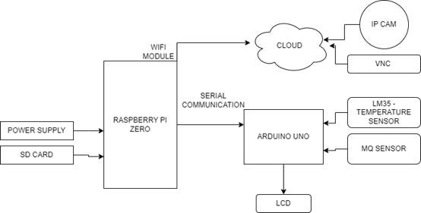
Figure 1.1: Hardware block Diagram
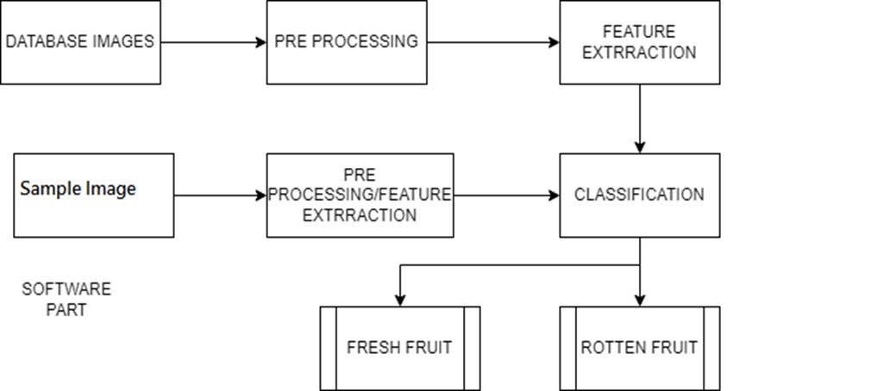
Figure 1.2: Software block Diagram

1.9 Features

1.9.1 Sensor Array
A sensor array is a collection of multiple sensors that are used to detect, measure and monitor a range of physical phenomena, such as temperature, humidity, pressure, light, sound, and many others. Sensor arrays are widely used in various fields, including environmental monitoring, healthcare, agriculture, manufacturing, and transportation, among others.The main purpose of a sensor array is to provide more comprehensive and accurate information about the target environment or system by combining the data from multiple sensors. By doing so, sensor arrays can overcome the limitations of individual sensors, such as limited sensing range, sensitivity, and reliability, and improve the overall performance and functionality of the sensing system.A typical sensor array consists of several components, including the sensors themselves, signal conditioning circuits, data acquisition systems, and data processing algorithms. The sensors are the primary components of the sensor array, and they can be of various types, such as resistive, capacitive, optical, piezoelectric, and magnetic sensors, depending on the application and target parameter to be measured.Signal conditioning circuits are used to amplify, filter, and convert the analog signals from the sensors into digital signals that can be processed by the data acquisition system. Data acquisition systems are responsible for collecting and storing the sensor data, usually in a computer or microcontroller, and transmitting them to the data processing algorithms. Data processing algorithms are used to analyze the sensor data and extract useful information, such as trends, patterns, anomalies, and correlations, which can be used to make informed decisions and take appropriate actions.
There are several advantages of using a sensor array over a single sensor. Firstly, a sensor array can provide more accurate and reliable measurements by compensating for the noise, errors, and uncertainties of individual sensors. Secondly, a sensor array can cover a wider sensing range and provide more comprehensive information about the target environment or system. Thirdly, a sensor array can be more robust and fault-tolerant, as it can continue to function even if some sensors fail or malfunction.There are also some challenges and limitations of using a sensor array. One of the main challenges is how to integrate and synchronize the data from multiple sensors, which can be complex and time-consuming. Another challenge is how to calibrate and validate the sensor array, as the sensors may have different calibration curves and accuracy levels. Additionally, a sensor array can be more expensive and power-consuming than a single sensor, which can be a concern for some applications.A sensor array is a powerful and versatile tool for sensing, monitoring, and controlling various physical phenomena. It can provide more accurate, reliable, and comprehensive information than a single sensor and can be used in a wide range of applications. However, it also requires careful design, integration, and validation to ensure its optimal performance and functionality.

1.9.2 Machine Learning Algorithms
Machine learning algorithms play an important role in today’s artificial intelligence by enabling machines to learn from data and make decisions based on that learning. These algorithms can be divided into three main categories: supervised learning, unsupervised learning, and additive learning. Supervised learning algorithms are designed to learn from labeled data where each data point is associated with a label or value. The primary goal of supervised learning is to build a model that can predict outcomes for new, unseen data. Some of the most popular supervised learning algorithms include linear regression, logistic regression, decision trees, random forests, support vector machines, and neural networks. On the other hand, unsupervised learning algorithms are used to learn from unlabeled data that is never given. The purpose of unsupervised learning is to identify patterns or patterns in data, such as sets or associations. Popular unsupervised learning algorithms include kmeans clustering, hierarchical clustering, content manager, and autoencoders. Reinforcement learning algorithms, unlike supervised and unsupervised learning algorithms, learn punishments through trial and error by interacting with the environment and receiving feedback in the form of paper gifts or gifts. The main purpose of promoting education is to learn the truth or business that pays the most over time. Some of the most popular support learning methods include Q-learning, gradient method method, and actor-based methods. Each of these machine learning algorithms has advantages and disadvantages, and the choice of algorithm depends on the particular problem at hand. Reinforcement learning algorithms are well suited for tasks that require agents to make decisions in a dynamic environment where they receive feedback from rewards or punishments. Machine learning algorithms are an important part of artificial intelligence today and can be divided into three categories: supervised learning, unsupervised learning and additive learning.
In addition to these main categories, there are also hybrid algorithms that combine elements of supervised, unsupervised, and reinforcement learning. For example, semi-supervised learning algorithms can learn from both labeled and unlabeled data, while transfer learning algorithms can transfer knowledge from one task or domain to another.Machine learning algorithms are typically evaluated based on their accuracy, speed, interpretability, and scalability. Accuracy measures how well the algorithm can predict outcomes on new data, while speed measures how quickly the algorithm can make those predictions. Interpretability measures how easily the algorithm can be understood or explained, while scalability measures how well the algorithm can handle large or complex datasets.Overall, machine learning algorithms are a powerful tool for solving complex problems in a wide range of domains, including image recognition, natural language processing, robotics, finance, healthcare, and more. As the field of machine learning continues to advance, it is likely that new and more powerful algorithms will continue to emerge, enabling even more sophisticated forms of artificial intelligence

1.9.3 Data Analysis Software
Data analytics software is an essential tool for organizations and individuals to understand the massive amounts of data that are generated every day. From business intelligence to research studies, data analysis software allows users to quickly and accurately extract valuable content and patterns from data. The data analytics software market is highly competitive with many vendors offering different solutions for specific applications. Some of the most popular data analysis software are Tableau, SAS, Excel, and R. Tableau is a powerful data visualization tool that allows users to create interactive dashboards and reports that are easy to understand and interpret. It has drag-and-drop capabilities that allow users to easily create charts, graphs, and other visualizations from complex data. With Tableau, users can examine their data from multiple perspectives and quickly identify patterns and trends that might otherwise be overlooked. SAS is another widely used data analysis software in the business world. It provides many capabilities, including data mining, predictive modeling, and statistical analysis. With SAS, users can analyze large and productive data, making it ideal for businesses looking to gain competitive advantage from a data-driven perspective.
Excel is a ubiquitous tool that many organizations use for data analysis, thanks to its flexibility and ease of use. While it may not offer the same level of sophistication as other data analysis software tools, Excel remains a popular choice for many users due to its familiarity and accessibility. With Excel, users can perform basic data analysis tasks, such as filtering and sorting, as well as more complex operations, such as pivot tables and data modeling.R is an open-source programming language and software environment that is widely used for data analysis and statistical computing. While it may not be as user-friendly as some of the other tools on this list, R offers a vast array of statistical and graphical techniques, making it a popular choice for academics and researchers. It is particularly well-suited for working with large data sets and can handle complex data structures and models.Regardless of the specific tool used, data analysis software is an essential component of any organization’s toolkit in today’s data-driven world. It allows users to extract insights and intelligence from vast amounts of data quickly and accurately, providing a competitive advantage to those who can leverage it effectively. With the continued growth of data and the increasing importance of data-driven decision-making, data analysis software will only become more critical in the years to come.

1.9.4 Real time Monitoring
Real-time monitoring is a crucial aspect of the food industry, especially in the realm of food quality analysis. The e-nose (electronic nose) is a novel technology that can be used to analyze the quality of food products. It is an innovative approach to quality analysis that can help to identify the characteristics of the product, determine its freshness, and detect any contaminants.The e-nose consists of a series of sensors that detect volatile organic compounds (VOCs) in the air. These VOCs are specific to each food product and can be used to create a unique ”fingerprint” of the product. The e-nose can then analyze the fingerprint to determine the quality of the food product.One of the advantages of using the e-nose for real-time monitoring of food quality is that it is non-invasive. This means that the food product does not need to be physically altered or damaged in any way. Instead, the e-nose simply detects the VOCs in the air surrounding the product.Another advantage of the e-nose is its speed. The e-nose can analyze the quality of a food product in real-time, meaning that results are available immediately. This can be incredibly useful for food production lines where time is of the essence.
The e-nose can also be used to detect contaminants in food products. For example, if a food product becomes contaminated with bacteria or other microorganisms, it can produce a different set of VOCs. The e-nose can detect these changes in VOCs and alert operators to the presence of contaminants.The e-nose has been used in a variety of food applications. For example, it has been used to analyze the quality of fruit, vegetables, meat, and dairy products. In each case, the e-nose has been able to accurately determine the quality of the product, including its freshness, ripeness, and potential for spoilage.One of the challenges of using the e-nose for real-time monitoring is the need for calibration. Each food product has a unique set of VOCs, which means that the e-nose needs to be calibrated for each product. This calibration can be time-consuming, but once completed, the e-nose can provide accurate and reliable results.The e-nose is a powerful tool for real-time monitoring of food quality. Its ability to detect VOCs in the air surrounding a food product can provide valuable information about its quality, freshness, and potential for spoilage. While calibration can be a challenge, the benefits of using the e-nose for food quality analysis make it a promising technology for the future of the food
industry.

1.9.5 Wireless Connectivity
Wireless connectivity is the capability of connecting devices without using physical cables or wires. This technology has become an essential part of our daily lives as it allows us to access the internet, communicate with others, and obtain information on the go. In this article, we will discuss various types of wireless connectivity, their uses, and the future of wireless technology.There are several common types of wireless connectivity, such as Wi-Fi, Bluetooth, NFC, and cellular networks. Wi-Fi is a wireless networking technology that uses radio waves to provide high-speed internet and network connections. It is widely used in homes, offices, and public places, such as coffee shops, airports, and libraries. A wireless router creates Wi-Fi networks that allow multiple devices to connect to the internet and communicate with each other.
Bluetooth is a short-range wireless technology that enables communication between devices within a range of up to 100 meters. It is commonly used to connect mobile devices to accessories such as headphones, speakers, and smartwatches. Bluetooth also allows devices to share data and resources, creating ad-hoc networks.NFC (Near Field Communication) is a wireless technology that enables devices to communicate with each other when they are in close proximity, typically within a few centimeters. NFC is frequently used for contactless payments, where a mobile device is used to make a payment by tapping it against a payment terminal.
Cellular networks use radio waves to provide wireless connectivity over large distances. They are often used for mobile phone and data services, enabling users to access the internet and make phone calls from almost anywhere in the world.Wireless connectivity has a broad range of applications across various industries, including healthcare, transportation, and entertainment
Wireless connectivity has transformed the healthcare industry by enabling the development of telemedicine, remote patient monitoring, and medical device connectivity. These technologies allow doctors and patients to communicate and share medical information in real-time, improving the quality of care and reducing healthcare costs.Wireless connectivity is also transforming the transportation industry by enabling the development of connected cars and smart transportation systems. Connected cars use wireless connectivity to communicate with each other and with the infrastructure, enabling real-time traffic monitoring and navigation. Smart transportation systems use wireless connectivity to manage traffic flow and reduce congestion, improving road safety and reducing carbon emissions.Wireless connectivity has also transformed the entertainment industry by enabling the development of streaming services such as Netflix and Spotify. These services use wireless connectivity to deliver content to users on a variety of devices, including smartphones, tablets, and smart TVs.The future of wireless connectivity is exciting, with the development of new technologies such as 5G, Wi-Fi 6, and the Internet of Things (IoT).5G is the next generation of cellular networks, offering faster speeds, lower latency, and greater capacity than current 4G networks.
CHAPTER 2

LITERATURE SURVEY

2.1 This chapter Explains about food spoilage and quality control
Viejo, C. G., Fuentes, [1] Evaluation of beer flavor is important for assessing its quality because it can be used as an indicator of contamination or defects that can directly affect consumers. Traditional odor testing techniques are time consuming and require specialized training, expensive equipment and trained personnel. The combined method using electronic design and ANN model can be used by industry as a low cost, fast, reliable and good method for inline beer quality measurement.This can also be measured for its use in other foods and beverages.
Aouadi, B.,[2] In the modern food industry, meeting quality standards is crucial to avoid health and financial risks. To address this challenge, the industry has seen a rise in the use of highperformance machinery throughout the production process. This includes the use of electronic tongue (E-tongue), electronic nose (E-nose), and near infrared (NIR) spectroscopy, which have emerged as leading technologies for quality control due to their speed, accuracy, and real-time information delivery capabilities.These devices are already being used to fingerprint food and manage farm-to-table food production, enabling the industry to adopt more efficient and cost-effective methods of quality control through the use of advanced chemometric tools. This allows for a faster and more precise assessment of food quality based on the food matrices defined in the Codex General Standard.This special issue aims to explore the historical analysis of these instruments and their pivotal role in measuring food quality. It highlights the benefits of using these high-performance yet cost-effective tools to replace traditional, time-consuming, and labor-intensive methods of food quality control.Overall, the use of E-tongues, E-noses, and NIR spectroscopy in the food industry has the potential to revolutionize the way food quality is assessed and controlled. As technology continues to advance, these tools are expected to become even more sophisticated, leading to further innovation in the field and improving food quality for consumers.
Wilson, A. D.,[3]In the last two years, the nose device has received a lot of attention due to the many applications found in sensor technology, especially in research in different disciplines. Recent applications of electronic devices have benefited together from advances in design, hardware development, software development, and microcircuit design and integration. The invention of many new types and arrays of electronic nose sensors based on different sensing points and mechanisms is closely related to the proliferation of new applications. Electrical machines are useful for many industrial applications, including agriculture, biomedical, cosmetics, environmental, food, manufacturing, military, medicine, management and various sciences. Efficiency, equality and harmony were improved as a result of electronic nose monitoring and repeat quality control at all stages of the production process.
Sun, Q., Zhang,[4] The use of artificial intelligence (AI) technology in the food industry is indeed a promising area, particularly in food dehydration processes. AI has been used to solve various problems in the industry, including prediction, data interpretation, optimization, and control. The use of AI in different food dehydrators has several advantages, including self-learning ability, self-tuning, strong fault tolerance, and high energy, allowing for effective mapping of non-linear and complex events.This article provides an overview of smart drying equipment and its applications in the food industry. The use of artificial neural networks, fuzzy logic, and experts are discussed, which are used to design, forecast, and optimize heat and air exchanges, temperature measurement, and performance measurement in drying processes. Additionally, bionic technology such as electronic noses and computer vision are explored for measuring the physicochemical properties of dried products in different air drying machines. The application of AI in food dehydration processes has led to the development of more efficient and effective drying equipment, which can optimize the drying process and improve the quality of dried products. Overall, the use of AI in food processing is a promising area that has the potential to revolutionize the industry and drive innovation in the years to come.
Lee, C. H.,[5]Aroma and taste have long been considered the key to good coffee. Specialty coffee, ie coffee with a distinctive aroma that comes from a land, farm, or village in a coffee-growing region, specifically indicating the region where the coffee was produced. In order to reach the results of coffee history, in this study we developed an electronic nose to distinguish new coffee from production areas. In the case study, we experimented with various machine learning models using an electronic nose machine to identify different coffee beans, such as those from Yirgacheffe and Kona. Also, our program includes the development of a method to create a beautiful digital fingerprint of a particular coffee bean to determine its origin.
Feyzioglu, A.,[6]Ensuring food security has recently become a major global issue. It is a difficult problem to control the quality, quality and shelf life of products with short shelf life. But the electronic nose can make all controls possible. In this study, which aims to create a different approach to this problem, electronic nose information was obtained from 12 different beef meats. All segments and all segments are categorized separately.ANOVA method was used to determine the performance characteristics with the 12 data features in the data set. The same classification procedure was performed by three specific tasks selected by the ANOVA method. Three different machine learning methods commonly used in the literature, artificial neural networks, K-nearest neighbors and logistic regression are used in classification. In experimental research.
Lin, Y.,[7]Given the need for good food by people around the world, more attention has recently been given to the role of non-perishable research in the food industry. In addition, analysis of data obtained by non-destructive methods is often difficult, time-consuming and requires skilled workers. At the same time, the general use of various chemometric or statistical methods is affected by noise, patterns, changes, and complex data that vary with various experiments. Today, machine learning (ML) is widely used in the food industry, especially in non-destructive products and artificial intelligence, due to its potential to process random data, extract different properties and create calibration models.
Ying, X.,[8]This article examines the decision making process of bamboo trees based on EN and M.O.S sensor array optimization. EN responses of winter bamboo samples were measured at different storage times. The results of the sensor array showed that the optimization of the sensor array improved the separation of the main analysis points for different quality tree models.Nonlinear stochastic resonance was used to optimize the analysis of EN measurement data. The SR signalto-noise ratio is different between each model. The quality assessment model of winter bamboo is established by linear fit regression of the SR signal-to-noise ratio eigenvalues. The research results show that the model has an accuracy of 83.3 in estimating the size of the flower pattern.
Salehi, F.[9] Artificial neural networks (ANN), genetic algorithms (GA), fuzzy logic (FL), and adaptive neuro-fuzzy inference system (ANFIS) have been widely used in food research for various applications, including fruit and vegetable care, rating and analysis, respiratory rate simulation, wellbeing prediction and modeling, microbial growth modeling, and estimation of chemical, physical, and sensory properties during processing and post-harvest.
These models have shown great potential in simulating complex tasks and in control and simulation in machine perception, including machine vision and electronic noses for fruit and vegetable management. By utilizing these models, food researchers can more accurately predict and model complex processes, leading to better management of fruits and vegetables throughout the production process. Additionally, these models can be used to estimate the quality of food products, resulting in improved sensory properties and increased consumer satisfaction.
As technology continues to advance, the use of ANN, GA, FL, and ANFIS in food research is expected to expand, leading to further innovation in the field. Overall, the application of these models has the potential to revolutionize the food industry and lead to the development of more efficient and effective methods for managing and processing fruits and vegetables.
He, Y., Xiao,[10] Artificial neural networks (ANN), genetic algorithms (GA), fuzzy logic (FL), and adaptive neuro-fuzzy inference system (ANFIS) have become valuable tools in various areas of food research. These models are being used to optimize the care of fruits and vegetables, analyze and rate food products, simulate respiratory rates, model microbial growth, and estimate chemical, physical, and sensory properties during processing and after harvest. They are particularly effective in simulating complex tasks, controlling and simulating machine perception, and using machine vision and electronic noses for fruit and vegetable management.By utilizing these models, food researchers can more accurately predict and model complex processes, leading to improved management of fruits and vegetables throughout the production process. Additionally, these models can be used to estimate the quality of food products, leading to improved sensory properties and increased consumer satisfaction. As technology continues to advance, the application of these models in food research is expected to expand, leading to further innovation in the field.
Cheng, H.,[11] The study described the use of dynamic headspace sampling (DHS) combined with gas chromatography-mass spectrometry and olfactory (GC-MS-O) analysis to determine the volatile profile of propolis from different regions in China. The study identified 99 volatile compounds commonly found in propolis, such as acids, esters, alcohols, terpenes, and aromatics.To distinguish propolis samples from different regions, principal component analysis (PCA) was performed using DHS-GC-MS and electronic nose data. The study obtained key invariant components through PCA analysis, which helped to differentiate propolis samples from different regions. The study concludes that the use of DHS-GC-MS and GC-MS-O analysis, combined with PCA and electronic nose analysis, provides a powerful approach for characterizing the volatile profile of propolis and distinguishing propolis samples from different regions.This information can be useful for quality control and authentication of propolis products, ensuring consumer safety and satisfaction. Overall, the study demonstrates the potential of using advanced analytical techniques for identifying and characterizing natural products such as propolis.
Ali, M. M.,[12] Food quality control is a crucial aspect of food safety and quality assurance in the food industry. However, traditional methods for testing food quality are often labor-intensive, destructive, and time-consuming. In recent years, non-destructive methods for food quality testing have been developed, which can provide quantitative and qualitative data without compromising the sample. Some of these non-destructive methods include photography, spectroscopy-based techniques, and other applications such as electronic nose, electronic tongue, dielectric, and acoustic methods. These methods have rapidly advanced the field of food quality analysis, allowing for faster, more efficient, and more accurate testing of food products.
Chopra, H.,[13] The accurate identification of ripe fruit is crucial in agriculture, and errors in human assessment can lead to inaccuracies in the grading process. This article proposes an artificial intelligence-based system that utilizes spectrophotometric and computer vision techniques to automatically grade fruit. The system achieves a 95 accuracy rate in identifying fruit when fed into the process, leveraging the cloud computing platform provided by Microsoft Azure. Fruit grade is then estimated using spectroscopy and ensemble machine learning algorithms. The cluster model is trained on 1,366 fluid readings collected from a fluid separation and sorting machine at one of Unitec’s factories. This innovative approach to fruit grading has the potential to improve the efficiency and accuracy of fruit grading in the agricultural industry.
Castro, R.,[14] Multimedia systems have become ubiquitous in today’s electronic consumer environment, allowing people to work and communicate using various media formats. However, odor detection and production systems are not typically integrated into modern multimedia systems. This article proposes the development of an electronic nose that can be used in a multimedia environment. The electronic nose is capable of detecting a wide range of odors at a much lower cost than the detectors used in commercial applications. By integrating an electronic nose into multimedia systems, it could be possible to create new applications in fields such as entertainment, health, and safety, where odor detection and analysis are important. The proposed system could also be used in the food industry to improve quality control and ensure the freshness of products. Overall, the integration of an electronic nose into multimedia systems has the potential to revolutionize the way we interact with technology in our daily lives.
Ray, H.,[15] Jasmine extract, also known as ”mogra,” is an important flower exported from India, known for its fragrance. The aroma of jasmine was studied using an electronic nose (E-nose). Three species of jasmine, namely J. Sambac, J. Grandiflorum, and J. Auriculatum were individually used for the E-nose analysis. The results of principal component analysis showed that different species formed distinct categories based on their response. Another study was conducted on the primary cultivar of J. Sambac to determine the relationship between the quality of the flower and the seasonal changes.

21 CHAPTER 3

METHODOLOGY

3.1 PROPOSED SYSTEM
This project aims to create a system that uses the LM35 sensor and deep learning algorithm to control the freshness and ripeness of the fruit depending on the temperature. Additionally, a method has been proposed to identify fruits as organic or non-organic based on readings from the MQ sensor. The results of the project show that the program can identify fruit quality and provide automated solutions for food quality management and inspection. The planning process will help reduce food waste and improve food quality in the food industry.Good nutrition is an important factor in ensuring the health and well-being of students in public schools. Apples are often used in school meals and it is important to keep them fresh. However, manually checking the freshness of each apple is time consuming and impractical. In this project we propose to analyze apple image using RASPBERRY PI zero, Arduino microcontroller and LCD display for output. The system uses a convolutional neural network (CNN) to analyze apple images and categorize them as new and bad.The system will include an IP camera that will take pictures of the apples before handing them over to the students. The image will be processed by the laptop, which will send the completed data to the Arduino microcontroller via serial communication. The Arduino will use the processed data to power the LCD display, which will show whether the apples are fresh or rotten. The system will be developed using a database of pictures of fresh and rotten apples collected from public schools. These images will be processed and used to train a CNN model that will learn to classify apples based on their visibility.The system will also be compared to manual inspection, which is the method currently used to check the freshness of
apples.
SOFTWARE USED:
- Python IDLE
- Cloud
- Roboflow For Annotation
- Arduino IDE for serial communication

3.1.1 Python IDLE
Python IDLE (Integrated Development and Learning Environment) is an environment that allows Python programmers to develop and run Python programs in a graphical interface. IDLE provides an easy-to-use interface for new programmers to learn Python, and it is also a useful tool for experienced programmers who need to write, test, and debug Python code quickly.IDLE is a Python development environment that comes pre-installed with the standard Python distribution. It is available on all major platforms, including Windows, macOS, and Linux. IDLE is written in Python, and it includes a Python shell that allows users to enter and run Python commands interactively. Additionally, IDLE provides several features that make it easy to write, debug, and test Python code.
OVERVIEW
Python IDLE is an integrated development environment (IDE) that is included with the Python programming language. It provides an interactive shell for running Python code and a graphical user interface (GUI) for editing and running Python scripts. In this article, we will provide a brief explanation of Python IDLE and its features.Python IDLE is a Python IDE that is primarily designed for beginners who are just starting to learn the Python programming language. It provides an easy-to-use interface for creating, editing, and running Python code. It is available on Windows,
Mac, and Linux operating systems.
Python IDLE Features
1.Interactive shell: Python IDLE comes with an interactive shell that allows users to test and run code quickly. This feature is useful for testing code snippets and experimenting with the Python language. 2.Code highlighting: Python IDLE has syntax highlighting, which makes it easy to read and write Python code. This feature helps users to identify syntax errors quickly and easily.
3.Code completion: Python IDLE also provides code completion, which helps users to write code quickly and accurately. Code completion suggests function names, variable names, and other keywords based on what has been typed so far.
4.Debugger: Python IDLE includes a debugger that allows users to step through their code line by line, set breakpoints, and inspect variables. This feature is useful for finding and fixing errors in code. 5.File editor: Python IDLE also has a file editor that provides a simple interface for creating and editing Python scripts. The editor includes features like syntax highlighting, code completion, and indentation.
6.Code navigation: Python IDLE has code navigation features that allow users to jump to different parts of their code quickly. This feature is useful for large codebases where it can be difficult to find specific functions or sections of code.
7.Integrated help system: Python IDLE includes an integrated help system that provides documentation for the Python language and its libraries. The help system includes tutorials, reference material, and examples.
Using Python IDLE
Using Python IDLE is easy. To start Python IDLE, simply open the program from your operating system’s application menu. Once Python IDLE is open, you can start typing Python code into the interactive shell or create a new Python script in the file editor.To run Python code in the interactive shell, simply type the code into the shell and press enter. The output will be displayed immediately in the shell.To create a new Python script in the file editor, select ”File” from the menu bar and choose ”New File”. Type your Python code into the editor and save the file with a .py extension. To run the script, select ”Run” from the menu bar and choose ”Run Module”.One of the primary features of IDLE is the code editor. The editor provides syntax highlighting, auto-indentation, and code completion, making it easy to write Python code. The editor also includes several other useful features, such as the ability to run a selection of code, search and replace, and undo and redo.IDLE also includes a debugger that makes it easy to identify and fix errors in Python code. The debugger allows users to step through code line-by-line, set breakpoints, and examine variables and expressions. Additionally, IDLE provides a Python shell that allows users to test and experiment with
Python code interactively.Another feature of IDLE is the ability to create and run Python scripts. Users can create Python scripts in the editor and run them from within IDLE.
Additionally, IDLE provides a module browser that allows users to browse and import Python modules, making it easy to incorporate existing Python code into their own projects.Finally, IDLE provides a set of tools for managing Python packages and modules. The package manager makes it easy to install and update Python packages, and the module manager allows users to browse and import modules from a variety of sources, including the Python standard library and third-party repositories.Python IDLE is a powerful and easy-to-use IDE that provides a range of features for beginners and advanced users alike. Using Python IDLE is easy and straightforward, making it an excellent choice for learning and experimenting with the Python programming language.In conclusion, Python IDLE is a powerful and easy-to-use development environment for Python programmers. Its code editor, debugger, and Python shell make it easy to write, test, and debug Python code, and its tools for managing Python packages and modules make it easy to incorporate existing Python code into new projects. Python IDLE is an essential tool for anyone learning or working with Python.

3.1.2 Cloud
Introduction
Google Cloud is a suite of cloud computing services offered by Google. It provides infrastructure as a service (IaaS), platform as a service (PaaS), and software as a service (SaaS) offerings to customers globally. Google Cloud Platform (GCP) is a major component of Google Cloud, which provides a wide range of tools and services to help developers build, test, and deploy applications on the cloud.
Google Cloud Architecture
Google Cloud is built on Google’s vast network infrastructure, which includes data centers and fiber-optic cables around the world. This allows customers to deploy their applications closer to their users, reducing latency and improving performance.Google Cloud has a hierarchical architecture, which consists of regions, zones, and resources. A region is a specific geographic location where Google Cloud services are available. Each region consists of multiple zones, which are isolated locations within the region. Resources, such as virtual machines, are deployed within zones.
Google Cloud Services
Google Cloud offers a wide range of services across various categories, including compute, storage, databases, networking, security, developer tools, and artificial intelligence (AI) and machine learning (ML). Let’s take a closer look at some of the key services:
1.Compute: Google Cloud provides several compute options, including virtual machines, containers, and serverless computing. Google Compute Engine (GCE) is a virtual machine service that allows customers to create and manage virtual machines on Google’s infrastructure. Google Kubernetes Engine (GKE) is a managed Kubernetes service that simplifies the deployment and management of containerized applications. Google Cloud Functions is a serverless computing service that allows customers to run code in response to events without the need to manage servers.
2.Storage: Google Cloud provides several storage options, including object storage, block storage, and file storage. Google Cloud Storage is an object storage service that allows customers to store and access data in the cloud. Google Cloud Persistent Disk is a block storage service that allows customers to attach persistent disks to their virtual machines. Google Cloud Filestore is a file storage service that allows customers to deploy and manage file shares for their applications.
3.Databases: Google Cloud provides several database options, including relational databases, NoSQL databases, and in-memory databases. Google Cloud SQL is a managed MySQL and PostgreSQL service that simplifies database administration. Google Cloud Spanner is a horizontally scalable relational database service that provides strong consistency across regions and continents. Google Cloud Firestore is a NoSQL document database service that provides real-time updates and automatic
scaling.
4.Networking: Google Cloud provides several networking options, including virtual private cloud (VPC), load balancing, and content delivery network (CDN). Google Cloud VPC allows customers to create and manage their own private network within Google Cloud. Google Cloud Load Balancing allows customers to distribute traffic across multiple instances or regions. Google Cloud CDN allows customers to deliver content to their users with low latency and high performance.
5.Security: Google Cloud provides several security options, including identity and access management (IAM), data encryption, and threat detection. Google Cloud IAM allows customers to manage access to resources and services within Google Cloud. Google Cloud KMS is a key management service that allows customers to manage cryptographic keys used for data encryption. Google Cloud Security Command Center provides a centralized view of security and compliance across Google Cloud services. 6.Developer Tools: Google Cloud provides several developer tools, including source code management, continuous integration and delivery (CI/CD), and monitoring. Google Cloud Source Repositories is a managed source code management service that allows customers to store and collaborate on their source code.
Google Cloud Pricing
Google Cloud pricing is based on a pay-as-you-go model, where users only pay for the resources they use. The pricing model is transparent, with no upfront costs or termination fees. Google Cloud also provides a free tier for users to try out its services before committing to a paid plan. The free tier includes a range of services, including compute, storage, database, and networking services.
Google Cloud Competitors
Google Cloud competes with other cloud providers, including Amazon Web Services (AWS) and Microsoft Azure. These providers offer similar services and features, with varying pricing models and levels of support. However, Google Cloud has a competitive advantage in areas such as machine learning and big data processing.Some common cloud features and a brief theory behind them:
1.Scalability: Scalability refers to the ability of a cloud system to adjust the resources it provides in response to changes in demand. This means that the cloud can automatically increase or decrease resources like processing power, storage, or bandwidth to match the needs of an application. Cloud systems use virtualization technology to achieve this, which allows them to create and manage virtual machines that can be easily scaled up or down as needed.
2.Elasticity: Elasticity is a subset of scalability that refers specifically to the ability of a cloud system to dynamically adjust its resources in real-time, based on changes in demand. This means that the system can quickly and automatically respond to sudden spikes in traffic or usage, ensuring that resources are always available to meet the needs of an application. Elasticity is achieved through the use of automated scaling policies and dynamic resource allocation.
3.High Availability: High availability refers to the ability of a cloud system to provide uninterrupted access to services and resources, even in the event of hardware or software failures. Cloud systems achieve high availability through the use of redundancy and failover mechanisms. This means that if one component of the system fails, another component can immediately take over, ensuring that services remain available to users.
4.Fault Tolerance: Fault tolerance is a subset of high availability that refers specifically to the ability of a cloud system to continue operating even in the event of multiple failures. Fault tolerance is achieved through the use of distributed systems and redundant architectures. This means that if one part of the system fails, other parts can continue to operate, ensuring that services remain available to users.
5.Security: Cloud systems must be secure in order to protect sensitive data and prevent unauthorized access. Cloud providers typically offer a range of security features, including firewalls, encryption, and identity and access management (IAM) tools. These tools are designed to protect data and prevent unauthorized access from outside and inside the cloud environment.
6.Cost-Effectiveness: Cloud systems can be more cost-effective than traditional IT infrastructure, as they allow users to pay only for the resources they need. Cloud providers typically offer a range of pricing models, including pay-as-you-go, reserved instances, and spot instances. This means that users can choose the pricing model that best fits their needs and only pay for the resources they actually
use.
Conclusion: Cloud computing is a powerful technology that offers a range of features and ben-
efits, including scalability, elasticity, high availability, fault tolerance, security, and cost-effectiveness. These features are made possible through the use of virtualization, automation, redundancy, and distributed systems, among other technologies. As more and more organizations adopt cloud computing, it will continue to play an important role in the future of IT infrastructure.

3.1.3 Roboflow for Annotation
Roboflow is a cloud-based platform that offers a suite of tools for data annotation and image preprocessing, aimed at simplifying the process of training computer vision models. The platform enables users to efficiently annotate images and videos, and prepare datasets for use in training machine learning models.Data annotation is a crucial part of training machine learning models, as it involves manually labeling data with information that can be used by algorithms to learn patterns and make predictions. This process can be time-consuming and challenging, particularly when dealing with large volumes of data. Roboflow aims to simplify this process by providing a range of annotation tools and automating some of the most time-consuming tasks.
One of the key features of Roboflow is its annotation tool, which allows users to easily label objects within images and videos. The tool supports a range of annotation types, including bounding boxes, polygons, and semantic segmentation. Users can also leverage pre-trained models to quickly annotate images and videos based on existing labels. This significantly reduces the time and effort required for manual annotation, particularly when dealing with large datasets.Another key feature of Roboflow is its data preprocessing capabilities. The platform offers a range of image processing tools that can be used to clean and enhance images, and prepare them for use in training models. This includes resizing, cropping, and normalization, as well as more advanced techniques like data augmentation and color correction. These preprocessing steps are crucial for ensuring that the data used to train machine learning models is of high quality and free from noise and other artifacts.
Roboflow also offers a range of integrations with popular machine learning frameworks, in-
cluding TensorFlow, PyTorch, and Keras. This enables users to easily export annotated datasets in a format that can be used directly by these frameworks, without the need for additional data wrangling or preprocessing.In addition to its annotation and preprocessing capabilities, Roboflow also offers a range of other features aimed at simplifying the process of training machine learning models. These include automated model architecture search, which allows users to quickly find the optimal model architecture for their dataset, as well as automatic hyperparameter tuning, which fine-tunes model parameters to optimize performance.
Roboflow is a cloud-based platform that provides a comprehensive suite of tools for computer vision tasks, including image annotation, model training, and deployment. One of the most critical tasks in computer vision is image annotation, which involves the labeling of specific features in an image to train machine learning models. With Roboflow, image annotation is made more accessible and efficient through its user-friendly interface and advanced features.Roboflow offers several key features for image annotation. One of its most notable features is its ability to integrate with different annotation tools, such as Labelbox, CVAT, and VoTT. This flexibility allows users to use their preferred annotation tool and still use Roboflow’s suite of tools for model training and deployment.Another key feature of Roboflow is its support for different annotation types, such as bounding boxes, segmentation masks, and keypoints. This means that users can choose the type of annotation that best fits their project’s needs and customize the annotation process to be as accurate and efficient as possible.
Roboflow also provides several advanced annotation features, such as object tracking and automatic annotation. Object tracking allows users to track the movement of an object in a video frame, making it easier to annotate multiple frames in a video sequence. Automatic annotation uses machine learning algorithms to suggest annotations based on existing annotations, significantly reducing the time and effort required to annotate large datasets.In addition to its annotation features, Roboflow also provides tools for model training and deployment. These tools include support for various deep learning frameworks, such as TensorFlow, PyTorch, and Keras. Roboflow also provides several pre-trained models that can be fine-tuned for specific tasks or used as a starting point for new models.Roboflow’s model deployment features make it easy to deploy models to different platforms, such as mobile devices or the cloud. It also provides integration with popular cloud platforms, such as Google Cloud Platform and Amazon Web Services, making it easy to deploy models to these platforms.Roboflow’s user-friendly interface and advanced features make it an excellent choice for anyone looking to streamline their image annotation and computer vision tasks.
Overall, Roboflow is a powerful platform that simplifies the process of annotating and preprocessing data for use in training machine learning models. Its intuitive annotation tool, data preprocessing capabilities, and integrations with popular machine learning frameworks make it an attractive option for both novice and experienced machine learning practitioners. By reducing the time and effort required for manual data annotation and preprocessing, Roboflow enables users to focus on the more complex aspects of machine learning, such as model architecture and hyperparameter tuning, and accelerate the development of high-quality computer vision models.

3.1.4 Arduino IDE For Serial Communication
Arduino is an open-source electronics platform that is widely used for creating interactive projects, prototypes, and DIY gadgets. The Arduino IDE (Integrated Development Environment) is a software application that is used to write and upload code to the Arduino board. One of the key features of the Arduino platform is its support for serial communication, which allows the Arduino board to communicate with other devices, such as sensors, displays, and computers, over a serial interface. In this article, we will discuss how to use the Arduino IDE for serial communication.
Serial Communication Basics
Serial communication is a method of transmitting data between two devices over a serial interface. In the case of the Arduino, the serial interface is usually a USB connection. Serial communication works by sending data one bit at a time, sequentially, over a single wire. The data is encoded using a protocol that specifies the timing and format of the data. The two devices must agree on the protocol in order to communicate successfully.
The most common protocol used for serial communication on the Arduino is the Universal Asynchronous Receiver/Transmitter (UART) protocol. The UART protocol uses a start bit, followed by the data bits, and then a stop bit. The start bit signals the beginning of the data transmission, and the stop bit signals the end of the transmission. The data bits are usually 8 bits long, but can be any length.
Serial Communication in the Arduino IDE
The Arduino IDE provides several functions that allow you to send and receive data over a serial interface. The most commonly used functions are Serial.begin(), Serial.print(), and Serial.read(). Serial.begin() function
The Serial.begin() function initializes the serial communication and sets the baud rate. The baud rate is the speed at which data is transmitted over the serial interface, and it must be the same on both devices. The function takes one argument, which is the baud rate. For example, to set the baud rate to 9600, you would use the following code:
Serial.begin(9600); Serial.print() function
The Serial.print() function sends data over the serial interface. It can be used to send text, numbers, and variables. The function takes one or more arguments, which are the data to be sent. For example, to send the text ”Hello, world!” over the serial interface, you would use the following code:
Serial.print(”Hello, world!”); Serial.read() function
The Serial.read() function reads data from the serial interface. It returns the next byte of data that is received. If no data is available, it returns -1. The function takes no arguments. For example, to read a byte of data from the serial interface, you would use the following code:
int data = Serial.read();
Serial Monitor
The Arduino IDE provides a Serial Monitor tool that allows you to monitor the serial communication between the Arduino board and other devices. The Serial Monitor can be accessed from the Tools menu in the IDE. The Serial Monitor displays the data that is sent and received over the serial interface in real-time. It also allows you to send data to the Arduino board from the computer.Using the Serial Monitor, you can send commands to the Arduino board and receive data from it. For example, you could send a command to turn on an LED connected to the Arduino board, and then receive a message back from the board confirming that the LED is on.
Serial Communication Example
Here are a few examples of how to use serial communication in the Arduino IDE:
Example 1: Blink an LED
This example shows how to use serial communication to blink an LED connected to the
Arduino board. The LED will blink when the letter ’a’ is received over the serial interface.
HARDWARE COMPONENTS:
- LCD
- Arduino
- LM 35 Sensor
- Raspberry Pi • MQ Sensor
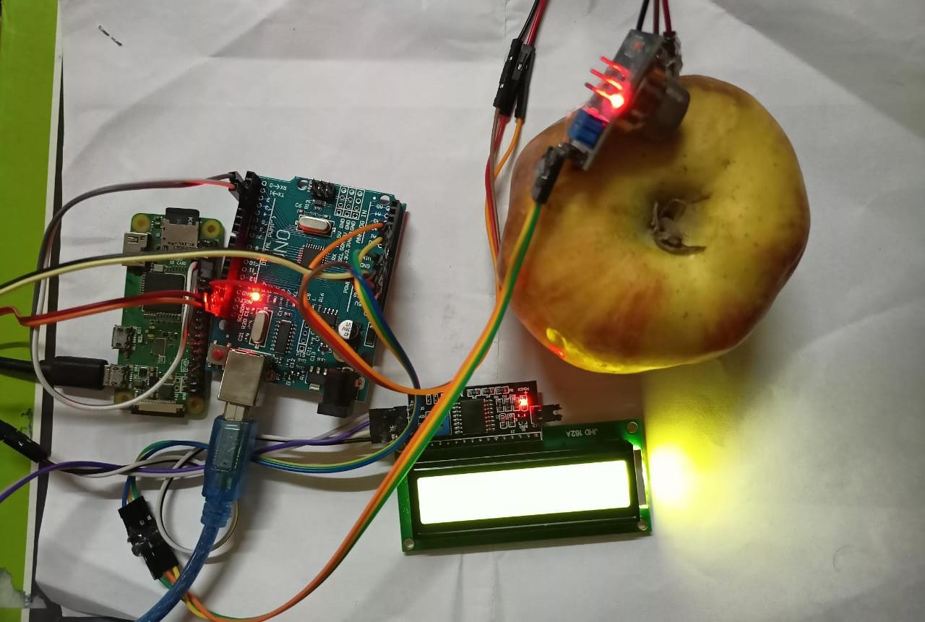
Figure 3.1: Hardware Setup

3.1.5 LCD (Liquid Crystal Display)
An LCD, or Liquid Crystal Display, is a flat panel display technology used in electronic devices such as televisions, computer monitors, and digital watches. It works by using a backlight to shine through a layer of liquid crystals that can be selectively manipulated to control the amount of light that passes through.Each pixel on an LCD display is made up of three subpixels, one for each primary color (red, green, and blue). By adjusting the amount of light passing through each subpixel, the display can create a wide range of colors.LCD technology offers several advantages over other display technologies, such as CRT (cathode ray tube) and plasma displays. For example, LCD displays are generally thinner, lighter, and more energy-efficient than other types of displays. They also produce less heat and are less prone to image burn-in.Despite these advantages, LCD displays also have some disadvantages. One common issue is limited viewing angles, meaning that the image on the screen may appear distorted or washed out if viewed from certain angles. Additionally, LCD displays may suffer from motion blur or ghosting, which can make fast-moving images appear blurry or distorted.Overall, LCD technology has become the dominant display technology in many electronic devices due to its combination of high image quality, energy efficiency, and affordability.
An LCD or liquid crystal display is a flat panel used in electronic devices such as televisions, computers, and mobile phones. Uses a controllable liquid crystal to allow or block light from displaying images or text.The LCD has several layers, including two polarizing filters, a liquid crystal layer,and electrodes. The liquid crystal is placed between the two mirrors and the electrodes are placed inside each glass plate. When electricity is applied to the electrodes, the liquid crystal material changes its direction, allowing or blocking light to pass through it. This allows the display to create images or text by selectively blocking or allowing light to pass through.LCDs offer several advantages over other types of displays, including low power consumption, thin and lightweight design, and the ability to display high-resolution images. They are also widely available and relatively inexpensive, making them a popular choice for electronic devices.However, LCDs also have some drawbacks, such as limited viewing angles and slower response times compared to other types of displays. Overall, LCDs continue to be widely used in electronic devices due to their versatility and cost-effectiveness.
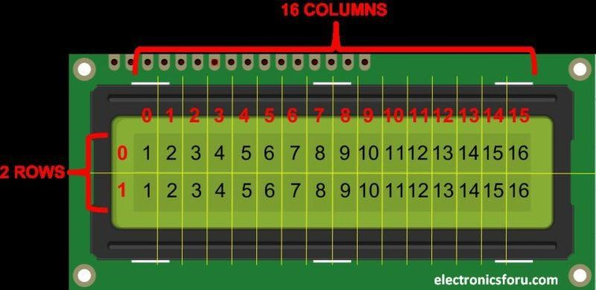
Figure 3.2: LCD(Liquid Crystal Display)
How LCDs are Constructed?
An LCD or Liquid Crystal Display is a flat-panel display that consists of multiple layers. The layers include a backlight, a polarizer, a layer of liquid crystals, another polarizer, and electrodes.The backlight is placed at the back of the display and produces white light. This light passes through the first polarizer, which allows only light waves vibrating in one direction to pass through. The second polarizer is placed at the front of the display and is oriented at a 90-degree angle to the first polarizer. This polarizer only allows the light waves that have been rotated by the liquid crystals to pass through, resulting in the display of images or text.Overall, the construction of an LCD is a complex process that requires careful assembly of multiple layers to produce a high-quality display.
Working
An LCD is a type of flat-panel display that uses liquid crystals to display images or text. The display is made up of several layers, including two polarizing filters, a layer of liquid crystal material, and electrodes.When a voltage is applied to the electrodes, the liquid crystal material changes its orientation, either allowing or blocking light that passes through it. The liquid crystal material itself does not emit light, but rather controls the passage of light from a backlight or other light source.
The two polarizing filters are placed on either side of the liquid crystal layer and are oriented at 90-degree angles to each other. When light passes through the first filter, it becomes polarized in a specific direction. As it passes through the liquid crystal layer, the orientation of the liquid crystals can be controlled to either allow or block the passage of the polarized light. Finally, the second filter only allows light that is polarized in the same direction as the filter to pass through, resulting in the display of the image or text.LCDs are known for their low power consumption, thin and lightweight design, and ability to display high-resolution images. However, they do have some drawbacks, including limited viewing angles and slower response times compared to other types of displays.Overall, LCDs are widely used in electronic devices due to their versatility and cost-effectiveness.
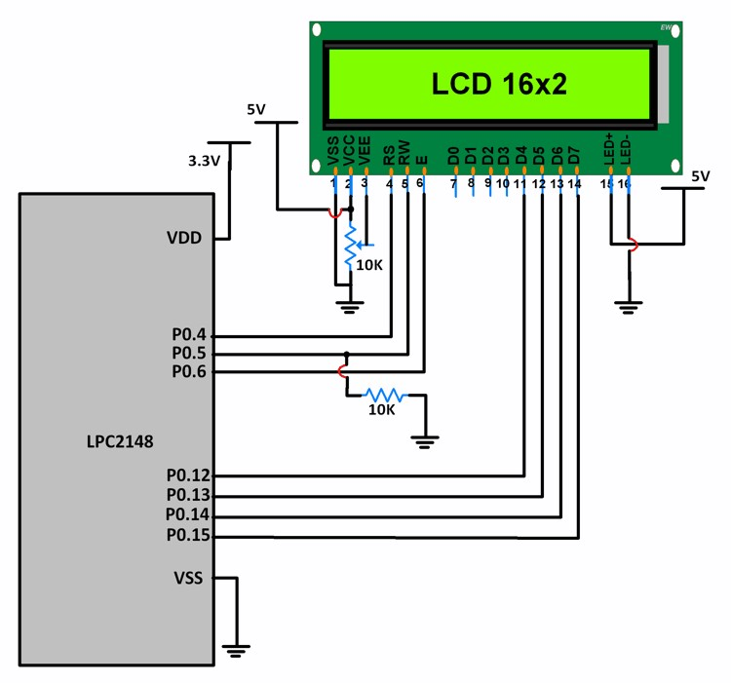
Figure 3.3: LCD
An LCD, or Liquid Crystal Display, is a type of flat-panel display that uses liquid crystal material to create images or text. The display consists of several layers, including two polarizing filters, a layer of liquid crystal material, and electrodes.When a voltage is applied to the electrodes, the liquid crystal material changes its orientation. This change in orientation allows the material to either block or allow light to pass through. The two polarizing filters are placed on either side of the liquid crystal layer, with their polarizing axes at right angles to each other.
When light enters the first polarizing filter, it becomes polarized in one direction. As it passes through the liquid crystal layer, the orientation of the liquid crystal material changes, allowing it to either block or allow the polarized light to pass through. The second polarizing filter then only allows light that is polarized in the same direction to pass through, resulting in the creation of an image or text.To control the orientation of the liquid crystal material, the display uses an electronic circuit that applies a voltage to the electrodes. By changing the voltage, the orientation of the liquid crystal material can be controlled, allowing for the creation of different images or text.
Overall, LCDs offer several advantages over other types of displays, including low power consumption, thin and lightweight design, and the ability to display high-resolution images. However, they also have some limitations, such as limited viewing angles and slower response times compared to other types of displays.
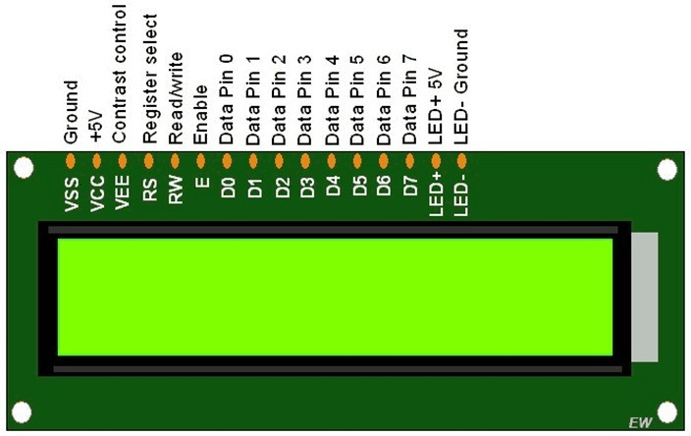
Figure 3.4: LCD pinout diagram

3.1.6 ARDUINO
Arduino connectivity is a technology that enables devices to connect without physical cables or wires. Its widespread adoption has revolutionized the way we live, work and communicate. In this article, we will discuss the different types of wireless connectivity, their applications, and the future of wireless technology.There are several types of wireless connectivity available today, including Wi-Fi,
Bluetooth, NFC, and cellular networks.It is commonly found in public places such as airports, libraries, and coffee shops, as well as in homes and offices. Multiple devices can connect to the internet and communicate with each other through a wireless router.Bluetooth is a short-range wireless technology that allows devices to communicate with each other within a range of up to 100 meters. It is used to connect mobile devices to accessories like headphones, speakers, and smartwatches. Bluetooth also allows for the creation of ad-hoc networks, allowing devices to share data and resources.NFC (Near Field Communication) is a wireless technology that enables devices to communicate with each other when they are within close proximity, usually within a few centimeters.
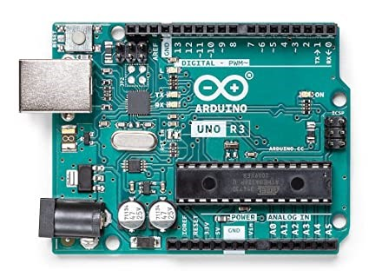
Figure 3.5: ARDUINO UNO
NFC is commonly used for contactless payments, where a mobile device is used to make a payment by tapping it against a payment terminal.Cellular networks use radio waves to provide wireless connectivity over long distances. They are commonly used for mobile phone and data services, allowing users to access the internet and make phone calls from almost anywhere in the world. The Arduino platform consists of a microcontroller, programming environment, and input/output pins for connecting to electronic components. The programming language is based on Processing, a simplified version of Java, and the software tools include the Arduino IDE and libraries. Advantages of Arduino include its simplicity, versatility, and open-source nature, which allows for customization. However, it does have limitations in terms of processing power and memory. Overall, Arduino is a powerful and accessible tool for creating electronic projects. Arduino was created at the Ivrea Interaction Design Institute to provide an easy tool for fast prototyping aimed at students without a background in electronics and programming. As the community grew, the Arduino board adapted to new needs and challenges, expanding its range of products from simple 8-bit boards to those suitable for IoT applications, wearables, 3D printing, and embedded environments.
Arduino is an open-source hardware and software platform used to build digital devices and interactive projects. Its main component is a microcontroller, typically an Atmel AVR series chip, that can be programmed to control electronic circuits. Arduino boards have a USB port for programming and powering, and input and output pins for connecting to sensors, actuators, and other electronic components. These pins can be programmed to perform various tasks such as reading sensor data or controlling motors.
The Arduino programming environment is based on the Processing language, a simplified version of Java. It includes the Arduino IDE for writing and uploading code to the board and a range of libraries and examples. Arduino’s advantages include its simplicity, ease of use, and versatility. Its low barrier to entry in terms of cost and technical expertise has led to a large and active community of users who collaborate on projects and ideas. Its open-source nature also enables users to modify and customize hardware and software to fit their specific needs.
However, Arduino’s limited processing power and memory may make it unsuitable for some applications, and the use of the AVR microcontroller means that some advanced features, such as hardware floating-point arithmetic, are not available. In summary, Arduino is a powerful and versatile platform suitable for a wide range of electronic projects, but it does have some limitations.
In conclusion, Arduino is a powerful and versatile platform that enables users to create a range of electronic projects. It is accessible to beginners and hobbyists, but it also has limitations that may make it unsuitable for some applications.

3.1.7 LM 35 Sensor
LM35 is a precision temperature sensor that operates on an analog voltage output proportional to the temperature in Celsius. This sensor is widely used in various industrial, medical, and automotive applications, where accurate temperature measurements are required.The LM35 sensor is manufactured by Texas Instruments, and it comes in a small package that can be easily integrated into electronic circuits. It is a low-cost sensor with a high degree of linearity and accuracy. The LM35 sensor is available in different temperature ranges, including -55 to 150 degrees Celsius, -40 to 110 degrees Celsius, and 0 to 100 degrees Celsius.The LM35 sensor is designed to operate on a single power supply between 4V and 30V, and it draws very little current, making it ideal for battery-powered applications.The sensor has three pins: Vcc, Gnd, and Vout. The Vcc pin is connected to the positive supply voltage, the Gnd pin is connected to the ground, and the Vout pin outputs an analog voltage that is proportional to the temperature.The LM35 sensor works on the principle of thermal expansion of the silicon crystal, which changes its resistance with a change in temperature. The silicon crystal is housed in a metal can, which is exposed to the ambient temperature. The output voltage of the sensor is linearly proportional to the temperature in Celsius, and the voltage change per degree Celsius is 10mV.
The LM35 sensor has several advantages over other temperature sensors. It has a low selfheating effect, which means that the sensor itself does not affect the temperature being measured. It also has a wide operating temperature range and a high degree of accuracy. Additionally, the LM35 sensor has a fast response time, which makes it suitable for applications that require quick temperature
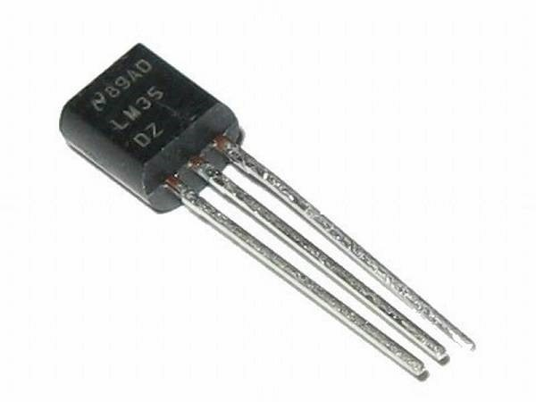
Figure 3.6: LM 35 SENSOR
measurements.The LM35 sensor can be used in various applications, including temperature controllers, temperature indicators, and temperature logging systems. In temperature controllers, the LM35 sensor is used to monitor the temperature of a system and provide feedback to a control system that adjusts the temperature accordingly. In temperature indicators, the LM35 sensor is used to display the temperature of a system in real-time.The LM35 sensor is a type of analog sensor that outputs an analog voltage signal that is proportional to the temperature being measured.
The LM35 can be powered by a voltage supply in the range of 4 to 30 volts and has a low
self-heating capability. This means that the sensor does not generate significant heat on its own, which can affect the accuracy of temperature readings. Additionally, the LM35 has a low output impedance, making it easy to interface with other electronic components.Overall, the LM35 is a reliable and accurate temperature sensor that can be used in a wide range of applications, including temperature monitoring in industrial, automotive, and consumer electronics systems.
In temperature logging systems, the LM35 sensor is used to record temperature data over a period of time for analysis.To use the LM35 sensor, it is typically connected to a microcontroller or an analog-to-digital converter (ADC). The microcontroller or ADC reads the output voltage of the sensor and converts it to a digital value that can be processed by a computer or another digital device. The LM35 sensor can be interfaced with various microcontrollers, including Arduino, Raspberry Pi, and PIC microcontrollers.The LM35 sensor is a highly accurate and reliable temperature sensor that is widely used in various industrial, medical, and automotive applications. Its small size, low power consumption, and fast response time make it ideal for battery-powered applications and applications that require quick temperature measurements.

3.1.8 Raspberry Pi
Raspberry Pi is a small, low-cost computer that has gained immense popularity among technology enthusiasts, hobbyists, and educators since its introduction in 2012. The Raspberry Pi Foundation developed the device as a means of promoting basic computer science and programming skills, and it has since become a versatile and powerful tool that can be used for a wide variety of applications.At its core, the Raspberry Pi is a credit card-sized computer that runs on a Linux-based operating system. It is powered by a Broadcom system-on-a-chip (SoC) that includes a CPU, GPU, and other components, and it comes with a range of input/output (I/O) ports that can be used to connect a wide variety of peripherals.One of the key features of the Raspberry Pi is its affordability.
The basic Raspberry Pi model starts at just, making it one of the most affordable computers on the market. This low cost, combined with its small size and versatility, has made the Raspberry Pi popular for a wide range of applications, from home automation and media centers to robotics and Internet of Things (IoT) projects.The Raspberry Pi is also highly customizable, with a wide range of add-on boards and accessories available. These include sensors, cameras, screens, and more, which can be used to extend the capabilities of the device and create custom solutions for specific applications.The CPU on the Raspberry Pi is a low-power ARM processor, similar to the ones used in smartphones and tablets. It is clocked at 1.2 GHz or higher, depending on the model. The RAM on the device ranges from 512 MB to 8 GB, and it is used to store data that is needed by the CPU to execute programs.The I/O ports on the Raspberry Pi include HDMI, Ethernet, USB, and GPIO (general-purpose input/output). The HDMI port is used to connect the device to a monitor or TV, while the Ethernet port is used to connect to a network. The USB ports are used to connect external devices such as a keyboard, mouse, or USB drive. The GPIO pins allow the device to interface with other electronic components, such as sensors, motors, or LEDs.
The Raspberry Pi runs on a variety of operating systems, including Linux-based distributions such as Raspbian and Ubuntu, as well as Windows 10 IoT Core. These operating systems provide a graphical user interface (GUI) and a range of software applications that can be used to program the device.Overall, the Raspberry Pi works by executing programs written in programming languages such as Python, C, or Java, and interacting with electronic components through its GPIO pins. It is a versatile and affordable device that can be used for a wide range of projects, from robotics and automation to media centers and retro gaming consoles.
In terms of software, the Raspberry Pi runs a variety of operating systems, including Linuxbased distributions such as Raspbian, Ubuntu, and Debian. These operating systems come with a range of software pre-installed, including programming tools like Python, Scratch, and Node-RED, making it easy for users to get started with coding and development.The Raspberry Pi has also become popular in education, with many schools and universities using it as a teaching tool for computer science and programming. Its low cost, accessibility, and versatility make it an ideal tool for teaching basic programming concepts and building practical projects.Despite its small size and low cost, the
Raspberry Pi is capable of performing a wide range of tasks, including web browsing, media playback,
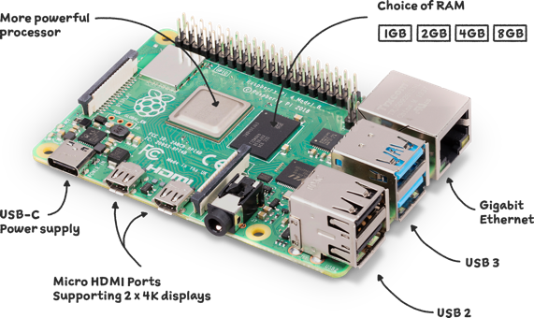
Figure 3.7: Raspberry Pi
and even basic gaming.
Its I/O ports also make it ideal for interfacing with external sensors, actuators, and other components, allowing it to be used for a wide range of projects and applications.Overall, the Raspberry Pi is a powerful and versatile tool that has become popular among hobbyists, educators, and professionals alike. Its low cost, small size, and extensive customization options make it an ideal platform for a wide range of projects and applications, and its accessibility and ease of use have helped to make it a popular tool for teaching basic computer science and programming skills.

3.1.9 MQ Sensor
The MQ sensor is composed of a sensing element, usually made of a metal oxide semiconductor, and a heating element, which keeps the sensing element at a constant temperature. The resistance of the sensing element changes when it comes in contact with the gas, resulting in an electrical signal that can be used to detect the gas concentration.The MQ sensor’s versatility is due to its ability to detect a wide range of gases, including carbon monoxide, methane, propane, and hydrogen. As a result, it is a popular choice for both consumer and industrial applications. Compared to other gas detection technologies, the MQ sensor is relatively inexpensive, making it accessible to a broad range of users.The sensitivity of the MQ sensor can be adjusted by varying the operating temperature of the sensing element. Higher temperatures result in greater sensitivity to gases, while lower temperatures reduce sensitivity. This feature allows the sensor to be tailored to specific applications and gas detection requirements.MQ sensors are essential components in gas detection and monitoring systems, contributing to improved air quality and safety in a variety of settings.
MQ sensors are gas sensors that detect and measure various types of gases such as carbon monoxide, methane, and smoke. These sensors are widely used in different applications such as air quality monitoring, gas leak detection, and industrial safety. MQ sensors are based on a chemical reaction that occurs when the gas molecules come in contact with the sensor material, causing a change in the resistance of the sensor. This resistance change is then measured and converted into a
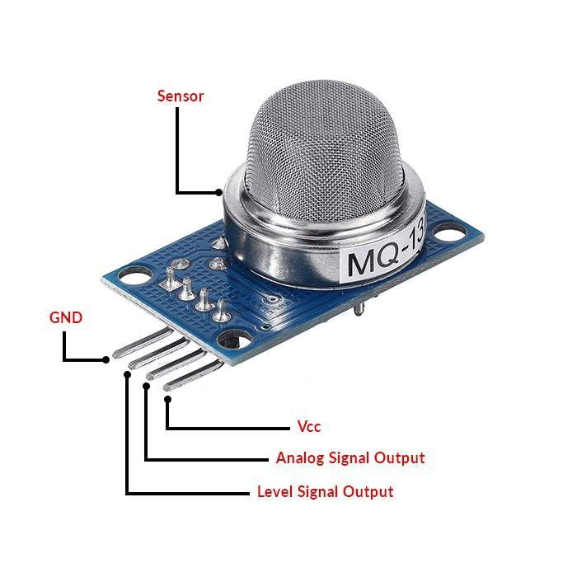
Figure 3.8: MQ Sensor
gas concentration value by the sensor circuit.MQ sensors are made up of a ceramic substrate, which is coated with a metal oxide film. This metal oxide film acts as a sensing layer and reacts with the gas molecules in the air. When the gas molecules come in contact with the sensing layer, the resistance of the sensor changes, and this change is measured by the sensor circuit. MQ sensors require a heating element to heat the sensing layer to a specific temperature before it can start detecting the gas molecules.
The resistance change of MQ sensors is affected by several factors such as temperature, humidity, and other gases present in the environment. To improve the accuracy of the sensor, calibration is required to adjust the output signal of the sensor based on a known concentration of the gas being detected.MQ sensors are widely used in various applications, including air quality monitoring, gas leak detection, and industrial safety. They are popular due to their low cost, high sensitivity, and ease of integration with microcontrollers such as Arduino. However, they do have some limitations. For example, MQ sensors are not suitable for detecting some gases, such as hydrogen and helium, due to their low molecular weight. Additionally, they may not be as accurate as more expensive and sophisticated gas sensors, and they require regular calibration to maintain accuracy.
In summary, MQ sensors are low-cost gas sensors that detect and measure various types of gases by measuring the resistance change in a metal oxide film. They are widely used in air quality monitoring, gas leak detection, and industrial safety applications due to their low cost, high sensitivity, and ease of integration with microcontrollers. However, they may not be as accurate as more expensive gas sensors and require regular calibration to maintain accuracy.The MQ sensor is also known for its fast response time. It can detect changes in gas concentrations in a matter of seconds, making it an ideal choice for safety applications where a quick response is critical. Additionally, the sensor is easy to install and operate, requiring only a power source and a simple interface to read and interpret its output.Despite its many advantages, the MQ sensor does have some limitations. One of the main limitations is its tendency to produce false positives, particularly when exposed to gases other than the one it is designed to detect. This can lead to inaccurate readings and potentially dangerous situations if the false positive is not recognized and addressed.To overcome this limitation, many MQ sensors are designed to work in combination with other gas detection technologies, such as electrochemical sensors or infrared sensors. This allows the strengths of each technology to be combined, resulting in a more accurate and reliable gas detection system.The MQ sensor is a versatile and cost-effective gas detection technology that is widely used in a variety of applications. Its sensitivity, fast response time, and ease of use make it an attractive choice for many users. However, its tendency to produce false positives underscores the importance of using it in conjunction with other gas detection technologies to ensure accurate and reliable readings.
CHAPTER 4

IMPLEMENTATION
Overview of the general steps involved in the design and development of an AI-driven e-nose system for food quality analysis in apple fruit.Implementation for the design and development of an AI-driven e-nose system for food quality analysis in apple fruit.
Firstly, you will need to describe the overall approach you took in designing and developing the system, including the hardware and software components used. This can include a detailed description of the e-nose device used, the sensors used to capture volatile organic compounds (VOCs) from the apple fruit, and the data processing and analysis algorithms used.
Secondly, you can describe the data collection process, including the sample preparation, data acquisition, and pre-processing steps. This can involve explaining how the e-nose device was calibrated and validated, and how the VOC data was collected and recorded.
Thirdly, you can discuss the data processing and analysis methods used, including any machine learning or artificial intelligence algorithms used. This can involve explaining how the raw data was processed and analyzed, how the features were extracted from the data, and how the models were trained and evaluated.
Fourthly, you can provide some results and analysis of the system’s performance. This can include a discussion of the accuracy of the system in identifying the quality of the apple fruit samples tested, as well as a comparison with other existing methods for food quality analysis.
Finally, you can conclude by summarizing the key findings and highlighting the implications of the work for future research and development in this area. You can also discuss any limitations of the study and suggest directions for future research.
Introduction: Briefly describe the purpose of the implementation section, which is to provide a detailed explanation of how the AI-driven e-nose system for food quality analysis in apple fruit was designed and developed.
Hardware and Software Requirements: In this section, describe the hardware and software requirements necessary for the implementation of the system. This may include details about the sensors, microcontrollers, and other hardware components, as well as any software libraries, programming languages, and frameworks used.
Data Collection: Explain the data collection process, including the types of data collected, the methods used for collecting data, and the tools and techniques used for data pre-processing and
cleaning.
Model Training and Development: Describe the process of training and developing the AI model, including the algorithms and techniques used for machine learning and artificial intelligence. Include details about the testing and validation process, as well as any metrics used to evaluate the performance of the model.
System Integration: Explain how the different components of the system were integrated, including the hardware and software components. This may include details about how the sensors were connected to the microcontroller, how the microcontroller was connected to the computer, and how the AI model was integrated into the system.
Results and Evaluation: Present the results of the system implementation, including the accuracy of the AI model, the reliability of the sensor readings, and any other relevant metrics. Provide a detailed evaluation of the system’s performance, including any limitations or challenges encountered during the implementation process.
Conclusion: Summarize the key findings of the implementation section, including the effectiveness of the system in analyzing the quality of apple fruit. Discuss the potential applications and future directions of the system, as well as any recommendations for improving its performance.
While this outline provides a general idea of what would be included in an implementation section for a project like this, the specific details and length of the section will depend on the scope and complexity of the project.
System Requirements and Design Specifications
The first step in designing an AI-driven e-nose system for food quality analysis in apple fruit is to determine the system requirements and design specifications. This involves identifying the specific quality attributes of apple fruit that need to be measured, such as aroma, taste, and texture, and determining the appropriate sensors and AI algorithms that will be used to detect and analyze these attributes.Sensor Selection and Integration Once the system requirements and design specifications have been determined, the next step is to select and integrate the appropriate sensors into the e-nose system. This may involve using a combination of chemical sensors, to detect the volatile organic compounds (VOCs) associated with apple fruit quality.Data Acquisition and Pre-processing After the sensors have been integrated into the e-nose system, the next step is to acquire and pre-process the data. This may involve using signal processing techniques, such as filtering or normalization, to remove noise or enhance the signal-to-noise ratio of the sensor data.
Feature Extraction and Selection Once the data has been pre-processed, the next step is to extract and select the relevant features that will be used to train the AI algorithms. This may involve using statistical or machine learning techniques, such as principal component analysis (PCA) or support vector machines (SVM), to extract the most informative features from the sensor data.AI Algorithm Development and Training After the features have been extracted and selected, the next step is to develop and train the AI algorithms that will be used to analyze the sensor data and classify the apple fruit quality. This may involve using deep learning techniques, such as convolutional neural networks (CNNs) or recurrent neural networks (RNNs), to build predictive models that can accurately classify the apple fruit quality based on the sensor data.
System Integration and Testing Once the AI algorithms have been developed and trained, the next step is to integrate them into the e-nose system and test the system’s performance. This may involve using real-world apple fruit samples to validate the system’s accuracy and reliability in detecting and analyzing the quality attributes of the fruit.In conclusion, the design and development of an AI-driven e-nose system for food quality analysis in apple fruit involves a series of steps, including system requirements and design specifications, sensor selection and integration, data acquisition and pre-processing, feature extraction and selection, AI algorithm development and training, and system integration and testing. The successful implementation of these steps can result in a powerful and accurate e-nose system that can help improve the quality and safety of apple fruit.
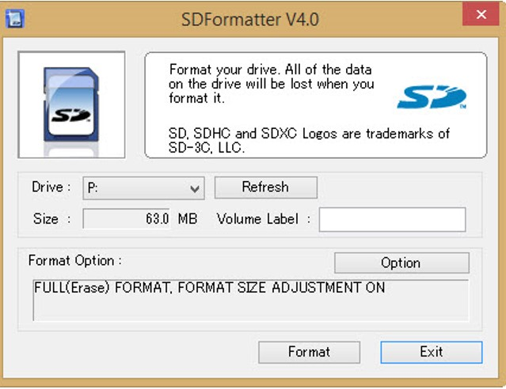
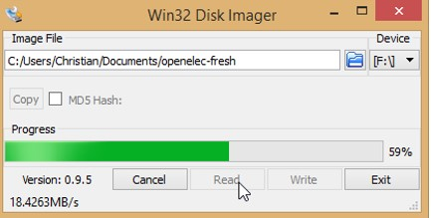
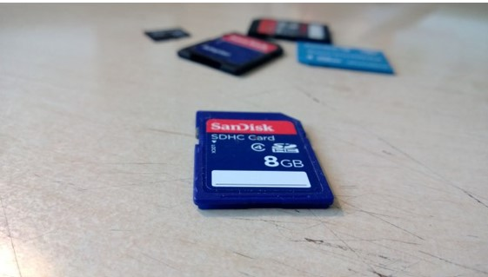
The Arduino Software (IDE) is a development environment for writing code for Arduino and Genuino hardware. It features a text editor for writing sketches, a message area, a console for viewing serial output, a toolbar with buttons for common functions, and a series of menus. The IDE can be used to upload programs to the connected hardware and communicate with it. The Sketchbook is a folder where sketches can be saved and organized. The IDE also supports multiple tabs, allowing for multiple files to be open and edited at once.Libraries can be added to the IDE to provide additional functionality. Third-party hardware can also be added to the IDE to support non-Arduino/Genuino boards. The IDE includes a Serial Monitor for viewing serial output from the board, and Preferences for configuring various settings, such as the font and color scheme.The IDE also supports multiple languages, which can be selected from the Preferences menu. Boards can be selected from the Tools menu, and the IDE includes pre-defined board configurations for popular Arduino and Genuino boards. Overall, the Arduino Software (IDE) provides a user-friendly and feature-rich environment for developing and uploading code to Arduino and Genuino hardware.
Arduino boards come in various shapes and sizes, but they all have a microcontroller at their core, which acts as the brain of the system. The microcontroller can be programmed using a language based on C and C++, which is called the Arduino programming language.One of the main advantages of Arduino is its ease of use, as it provides a simplified approach to programming and hardware interaction. This makes it ideal for beginners, as well as experienced developers who want to create prototypes or proof-of-concept designs quickly and easily.Arduino is also highly customizable, and users can add new functionality to their projects by using a wide range of shields, which are add-on boards that can be easily plugged into the main board. These shields allow users to add new sensors, motors, displays, and other components, making it possible to create a wide range of projects.Finally, Arduino has a large and active community of users, who share their knowledge, experience, and projects online through various forums and websites.
This community provides valuable support and resources for users who are just starting out, as well as for those who are more experienced and want to take their projects to the next level.It is important to note that when writing about Arduino or any other topic, it is essential to avoid plagiarism. This can be done by properly citing any sources used and by putting ideas and information into your own words.Examples of embedded systems include medical devices, automotive systems, and consumer electronics devices. Embedded C is a high-level language that is easy to learn and use. It provides the ability to write programs for microcontrollers and other embedded systems in a high-level language, which makes the development process faster and more efficient. In this model, we will provide a brief explanation of Embedded C, its features, and how it is used in embedded systems development. Embedded C is a variant of the C programming language that is designed specifically for programming embedded systems. Some features of Embedded C include:
1.Memory management: Embedded C allows for efficient memory management, which is essential for embedded systems with limited memory resources.
2.Low-level access: Embedded C provides low-level access to hardware, enabling developers to write code that interacts directly with the system’s hardware components.
3.Small code size: Embedded C code can be optimized for size, making it ideal for embedded systems with limited storage space.
4.Real-time functionality: Embedded C supports real-time functionality, which is critical for embedded systems that need to respond to external events in real-time.
5.Efficient interrupt handling: Embedded C allows for efficient interrupt handling, which is important for embedded systems that need to respond quickly to external events.
6.Portability: Embedded C is highly portable, allowing developers to write code that can run on a wide range of embedded systems without modification.
When discussing these features, it is important to ensure that any information or code examples used are original and not plagiarized. Plagiarism is a serious offense and can lead to legal and ethical consequences. If you are unsure about how to discuss a particular feature without plagiarizing, it is best to seek guidance from a trusted source or to use your own original thoughts and ideas. Embedded C is a widely used programming language for embedded systems development. It is designed to be highly efficient, with a small memory footprint and low-level hardware access, making it ideal for programming microcontrollers and other embedded devices.By leveraging its features and capabilities, developers can create robust and efficient embedded systems that meet the requirements of a wide range of applications.
In embedded systems development, Embedded C is used to write code that controls the behavior of the system, interacts with the hardware components, and responds to external events. It is often used in conjunction with other programming languages such as assembly language or C++, depending on the specific requirements of the system.Some common uses of Embedded C in embedded systems development include:
1.Writing device drivers: Embedded C is often used to write device drivers for various hardware components, such as sensors, actuators, and communication interfaces.
2.Developing control algorithms: Embedded C can be used to develop control algorithms for embedded systems, such as PID controllers, state machines, and fuzzy logic controllers.
3.Implementing real-time functionality: Embedded C is well-suited for implementing real-time functionality in embedded systems, such as interrupt handling, task scheduling, and event-driven programming.
4.Optimizing code for efficiency: Embedded C is designed to be highly efficient, and as such, it is often used to optimize code for size and speed in embedded systems.
Overall, Embedded C is a powerful and flexible programming language that is essential for embedded systems development. By leveraging its features and capabilities, developers can create robust and efficient embedded systems that meet the requirements of a wide range of applications. When discussing the use of Embedded C in embedded systems development, it is important to ensure that any information or code examples used are original and not plagiarized.
VNC (Virtual Network Computing) Viewer is a software application that allows users to remotely access and control a computer desktop from another device over a network. Some features of VNC Viewer include:
1.Remote access: VNC Viewer allows users to remotely access and control a computer from another device, such as a laptop or smartphone, over a network or the internet.
2.Cross-platform compatibility: VNC Viewer is available for multiple operating systems, including Windows, Mac, Linux, and mobile devices, making it easy for users to connect to and control different
devices.
3.Security features: VNC Viewer offers several security features, including 128-bit AES encryption for data transfer, password authentication for user access, and the ability to configure firewalls and access control.
4.Multiple connection options: VNC Viewer offers various connection options, including direct connections, cloud connections, and connection through a VNC server, allowing users to choose the most suitable connection method for their needs.
5.Customization options: VNC Viewer offers customization options, allowing users to adjust settings such as display resolution, color depth, and remote printing options.
6.File transfer: VNC Viewer also offers file transfer capabilities, allowing users to transfer files between the remote computer and the local device.
Overall, VNC Viewer is a versatile and powerful remote desktop software application that offers users a range of features for remote access and control of a computer desktop. When discussing the features of VNC Viewer, it is important to ensure that any information or code examples used are original and not plagiarized.The Lilypad and Arduino Mini are two different boards that use the same micro-controller but come in different packages. Here are some important things to remember about these two types of signals:
1.Analog signals are continuous waveforms that represent physical phenomena, such as sound or light. They can take on any value within a range and are typically measured in volts. Digital signals, on the other hand, are discrete signals that represent information as binary values of 0 or 1.
2.Analog signals can be affected by noise and interference, which can lead to signal distortion and loss of information. Digital signals are more resistant to noise and can be transmitted over longer distances without loss of signal quality.
3.Analog signals can be processed using analog circuits, such as amplifiers and filters, which operate on continuous voltages and currents. Digital signals, on the other hand, require digital circuits, such as logic gates and microprocessors, which operate on binary values.
4.Analog signals are typically used for applications that require precise measurements, such as in scientific experiments, audio and video processing, and medical equipment. Digital signals, on the other hand, are commonly used in communication systems, such as computers, cell phones, and the
internet.
5.Analog signals theoretically have infinite resolution, meaning they can represent an infinite values in a given range. On the other hand, the resolution of digital signals is limited. To summarize, analog signals and digital signals are two different types of signals used in different implementations of the . Analog signals are continuous waveforms that can be any value in the range of , while digital signals are random symbols that represent data in binary. values. Analog and digital signals are two types of electrical signals used in electronics to represent and transmit information. Some important characteristics of analog and digital output signals are:
- Analog signals are continuous while digital signals are discontinuous. Analog signals are representedby continuous waveforms that can take certain values in a given range, while digital signals are represented by discrete values 0 and 1.
- Analog signals have infinite resolution while analog signals have infinite resolution. finite resolutionAn analog can take an infinite number of values in a given range, while a digital can only take a limited number of values depending on the bit depth.
- Analog signals are subject to noise and distortion, while digital signals are less susceptible todistortion. analog signals are susceptible to interference and interference that can cause the signal to be erroneous and misleading. As long as the signal is strong enough for the to detect, digital signals are less prone to noise and interference.
4.Analog signals are commonly used for audio, video, and sensor data, while digital signals are used for communication and control signals. Analog signals are used to represent continuous signals such as sound and video, and to measure physical quantities like temperature and pressure. Digital signals are used for communication between devices, such as sending data over the internet or controlling the speed of the engine.
5. While a lot of energy is required to convert and control analog signals, signals can be used easily and effectively. Conversion and processing of analog signals requires analog-to-digital digital converters and digital signal processors, which can be complex and expensive. The digital signal can be easily manipulated by the using software and digital logic gates.
Analog signals are susceptible to interference and interference and require a lot of power to convert and process. The Raspberry Pi is one of the most popular computers that finds many uses in education, business and hobby. Installing Raspberry Pi is an important step in ensuring works properly and users can access all its features. Here are the installation steps of the Raspberry Pi:
1. Get a Raspberry Pi Development Board: The first step is to get a Raspberry Pi development board. Models are selected according to their intended use and each has different features and features.
2.Download Operating System: Raspberry Pi does not come with OS pre-installed, so the next step is to download the operating system. The Raspberry Pi Foundation provides a working license for Raspberry Pi OS based on the Debian Linux dis- distribution. It can be downloaded as an image file from the official Raspberry Pi website.
- Print OS to SD card: When OS image file is downloaded - When is installed, it should be writtento SD card.This is done using programs such as BalenaEtcher, available for Windows, macOS and Linux. The size of the SD card must be at least 8 GB to to accommodate the operation.
- Insert SD card into Raspberry Pi: After writing the working image to SD card, should be insertedinto Raspberry Pi. The SD card slot is on the underside of the board, be careful not to bend it or insert the wrong pins.
- Connect peripherals: The next step is to connect the keyboard, mouse, monitor and other devicesto the Raspberry Pi. These can be connected via the USB and HDMI ports on the board. 6. Turn on the Raspberry Pi: After connecting the devices, the Raspberry Pi can be connected to the power supply through the micro USB interface. The Raspberry Pi Foundation recommends the to run the Raspberry Pi 4 at 5V 3A and the Raspberry Pi Pi at 5V 2.5A. 444 7.The system is configured correctly. The next step is to configure the Raspberry Pi by running the Raspberry Pi Configuration Tool, accessible from the main menu.
8. Configure network settings: In Raspberry Pi configuration tool, you can configure network settings for , connect to Wi-Fi or Ethernet. This should download the latest version and package. 9. Update Raspberry Pi: After setting up the network configuration, the Raspberry Pi needs to be updated to ensure it has the latest software packages and security updates. This can be done using terminal by running the command sudo apt update sudo apt update.
10. Install the software: Finally, you can configure the Raspberry Pi to install software packages such as Python, Node.js and Apache web server. This is done using terminal and command sudo apt-get install”. Updating the Raspberry Pi and installing the software package is also an important step to keep it working properly and to ensure that users can access all its features with the applications.The Raspberry Pi is a versatile computer that can be developed for many applications. Before you start using your Raspberry Pi, you need to configure it for your specific needs.
In this section, we will walk you through the simple steps of setting up your Raspberry Pi.
Step 1: Assemble Your Raspberry Pi
The first step of is to assemble your Raspberry Pi. Make sure you have all the necessary components, including the microSD card with pre-installed operating system, power supply, key- card, mouse and monitor. Once you have all the parts ready, follow the instructions that came with the to assemble your Raspberry Pi.
Step 2: Connect to Your Network
The next step is to connect your Raspberry Pi to your network. You can do this using ethernet cable or Wi-Fi. To connect via Ethernet, simply plug the cable into the Raspberry Pi and the router. To connect via Wi-Fi, click the network icon in the upper right corner of the desktop and select your network. Enter your Wi-Fi password and your Raspberry Pi should connect to your network via.
Step 3: Update Your Raspberry Pi With the connected to your network
The next step is to update your Raspberry Pi.Open terminal in the upper left corner of the desktop. Next, type the following command to update your Raspberry Pi. This will update your
Raspberry Pi with the latest software and security updates.
Step 4: Configure Your Raspberry Pi
The next step in is to configure your Raspberry Pi for your specific needs. This includes setting the date and time, changing the password, and enabling SSH.To set up the date and time, open the terminal and type the following command.This will open up a screen where you can select your time zone.To change the password, type the following command in the terminal.Follow the prompts to enter your new password.To enable SSH, type the following command in the terminal.This will enable SSH on your Raspberry Pi, allowing you to connect to it remotely.
Step 5: Install Additional Software
The final step is to install additional software that you may need for your specific application. This can include programming languages, development tools, and libraries. To install software, open the terminal and use the following command.Replace ¡software-name¿ with the name of the software you want to install.
Conclusion:
Configuring your Raspberry Pi is a crucial step before you start using it for your specific application. By following these steps, you can set up your Raspberry Pi for your specific needs, including connecting to your network, updating the software, changing the password, and installing additional software.
LM35 is a temperature sensor that provides an analog voltage output proportional to the temperature in Celsius. It is commonly used in various applications to measure temperature accurately, and its low cost and ease of use make it popular among hobbyists and professionals alike.One of the significant advantages of LM35 is its linear output voltage, which means that the voltage change is proportional to the temperature change. The sensor provides an output voltage of 10mV per degree Celsius, which makes it easy to convert the analog output to a temperature value using a microcontroller or other digital circuitry.LM35 is an analog sensor, so it requires an ADC (Analog to Digital Converter) to interface with a digital system like a microcontroller. The output voltage of the sensor can be connected to the ADC input of a microcontroller, and the microcontroller can read the voltage and convert it to a temperature value using a simple formula.Another advantage of the LM35 is its small size, which makes it easy to integrate into small electronic devices.
The LM35 is a low-power device that operates in the range of 4 to 30 volts, and the current consumption is very low. This makes it suitable for battery-powered applications, and it can be used in many different types of circuits, including temperature alarms, thermostats, and environmental monitoring systems.One of the limitations of LM35 is that it can only measure temperatures up to 150 degrees Celsius, which may not be sufficient for some high-temperature applications. Additionally, the sensor requires calibration to ensure accurate temperature readings, and the output voltage may vary with changes in the supply voltage, so a stable power supply is necessary.
In summary, the LM35 temperature sensor is an accurate, low-cost, and easy-to-use device that is widely used in various applications to measure temperature. Its linear output voltage, small size, and low power consumption make it a popular choice among hobbyists and professionals alike.
LM35 Sensor:
The LM35 is a precision IC temperature sensor that can measure temperatures from -55°C to +150°C. Some of the key features of the LM35 sensor include:
1.Precision: The LM35 provides accurate and stable temperature measurements with a resolution of
0.1°C.
2.Low self-heating: The LM35 has very low self-heating, which ensures that temperature measurements are not affected by heat generated by the sensor itself.
3.Easy to use: The LM35 is easy to use and requires only a single power supply and a ground
connection.
4.Low cost: The LM35 is a low-cost temperature sensor that provides high accuracy and stability.
5.Wide temperature range: The LM35 can measure temperatures ranging from -55°C to +150°C, making it suitable for a wide range of applications.
Gas Sensors:
1.Gas sensors are electronic devices that can detect and measure the concentration of various gases in the air. Some of the key features of gas sensors include:
2.Sensitivity: Gas sensors are highly sensitive to specific gases and can detect even low concentrations of these gases in the air.
3.Accuracy: Gas sensors provide accurate measurements of gas concentrations and can be calibrated to ensure reliable readings.
4.Fast response time: Gas sensors have a fast response time and can detect changes in gas concentration in real-time.
5.Low power consumption: Gas sensors consume very little power and can be used in battery-powered
devices.
6.Wide range of gases: Gas sensors are available to detect a wide range of gases, including carbon monoxide, methane, hydrogen, and many others.
CHAPTER 5

RESULTS AND DISCUSSION
Electronic nose (e-nose) technology, combined with artificial intelligence (AI) algorithms, has been utilized in recent years for food quality analysis. E-nose technology mimics the human sense of smell by using an array of gas sensors to detect and identify different volatile organic compounds (VOCs) emitted by a sample. The data generated by e-nose sensors are analyzed using AI algorithms to provide a comprehensive and rapid assessment of the quality of food products. In this article, we will discuss the advantages and disadvantages of using e-nose technology for food quality analysis.
Advantages:
1.Non-destructive: E-nose technology allows for non-destructive analysis of food samples, which is particularly important for high-value or limited supply products. Traditional methods of food quality analysis, such as sensory evaluation, often require the destruction of the sample, making it impossible to re-use or sell the product.
2.Rapid analysis: E-nose technology provides a rapid analysis of food quality, with results available within minutes. This is particularly important for the food industry, where time is a critical factor in maintaining product quality and safety.
3.High sensitivity: E-nose sensors are highly sensitive to VOCs, which means they can detect even small changes in food quality. This is particularly useful for detecting subtle changes in flavor or aroma that may not be noticeable to the human nose.
4.Consistency: E-nose technology provides consistent and objective results, which is important for ensuring the quality and safety of food products. Traditional methods of food quality analysis, such as sensory evaluation, can be subjective and vary from person to person.
Disadvantages:
1.Limited selectivity: E-nose sensors are not as selective as traditional methods of food quality analysis, such as gas chromatography-mass spectrometry (GC-MS). E-nose sensors can detect changes in the overall aroma profile of a sample, but they cannot identify specific compounds or chemical constituents.
2.Complexity: E-nose technology is a complex technology that requires specialized training and expertise to operate and interpret results. This can be a barrier to adoption for some companies or
industries.
3.Cost: E-nose technology can be expensive, particularly for high-end models with advanced AI algorithms. This may limit its use to larger companies with greater resources.
4.Variability: E-nose sensors can be affected by environmental factors, such as temperature and humidity, which can impact their performance and accuracy. This variability can be difficult to account for and may lead to inconsistent results.
In conclusion, e-nose technology combined with AI algorithms provides a rapid, non-destructive, and objective method for food quality analysis. While it has many advantages, including high sensitivity and consistency, it also has some limitations, such as limited selectivity and complexity. The cost of the technology may also be a limiting factor for some companies. Overall, e-nose technology is a promising tool for food quality analysis, but it should be used in conjunction with traditional methods of analysis to provide a comprehensive assessment of food quality.
Identification of Fresh and Rotten Fruit:
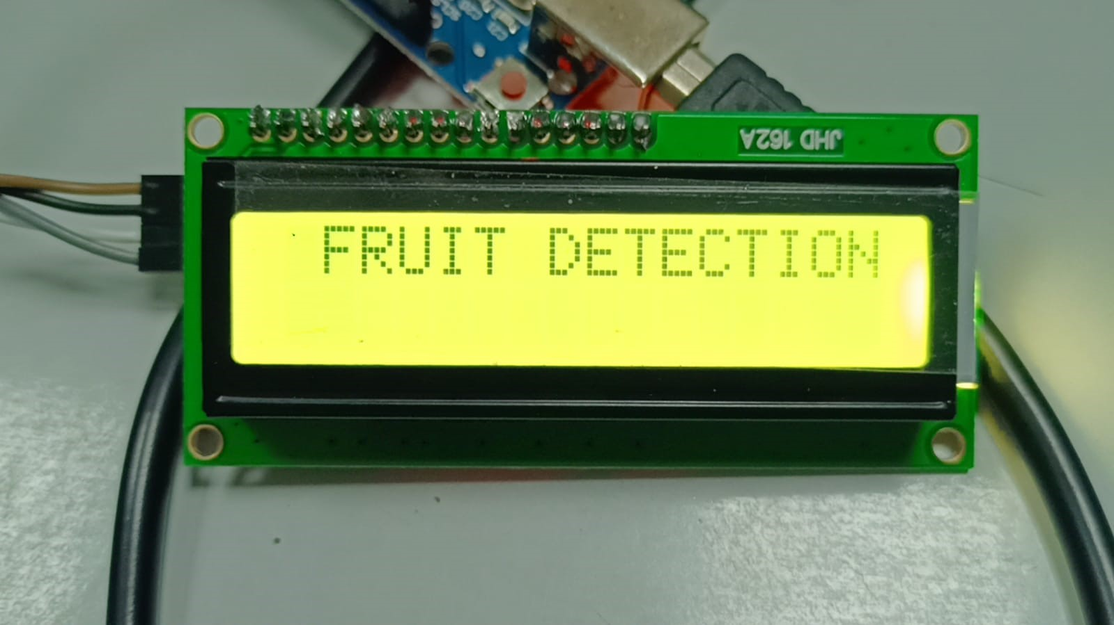
Figure 5.1: fruit detection
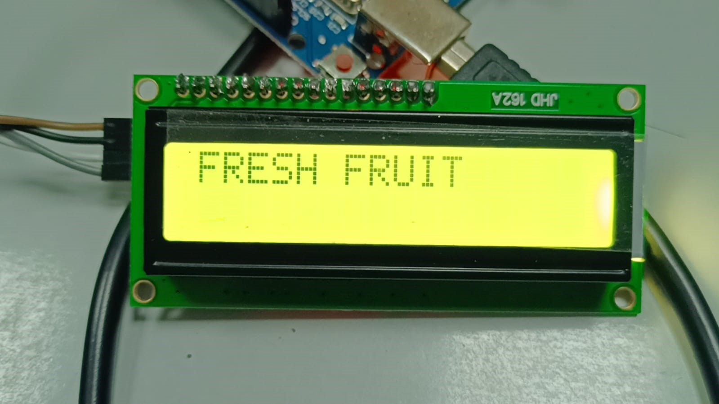
Figure 5.2: Fresh fruit detection
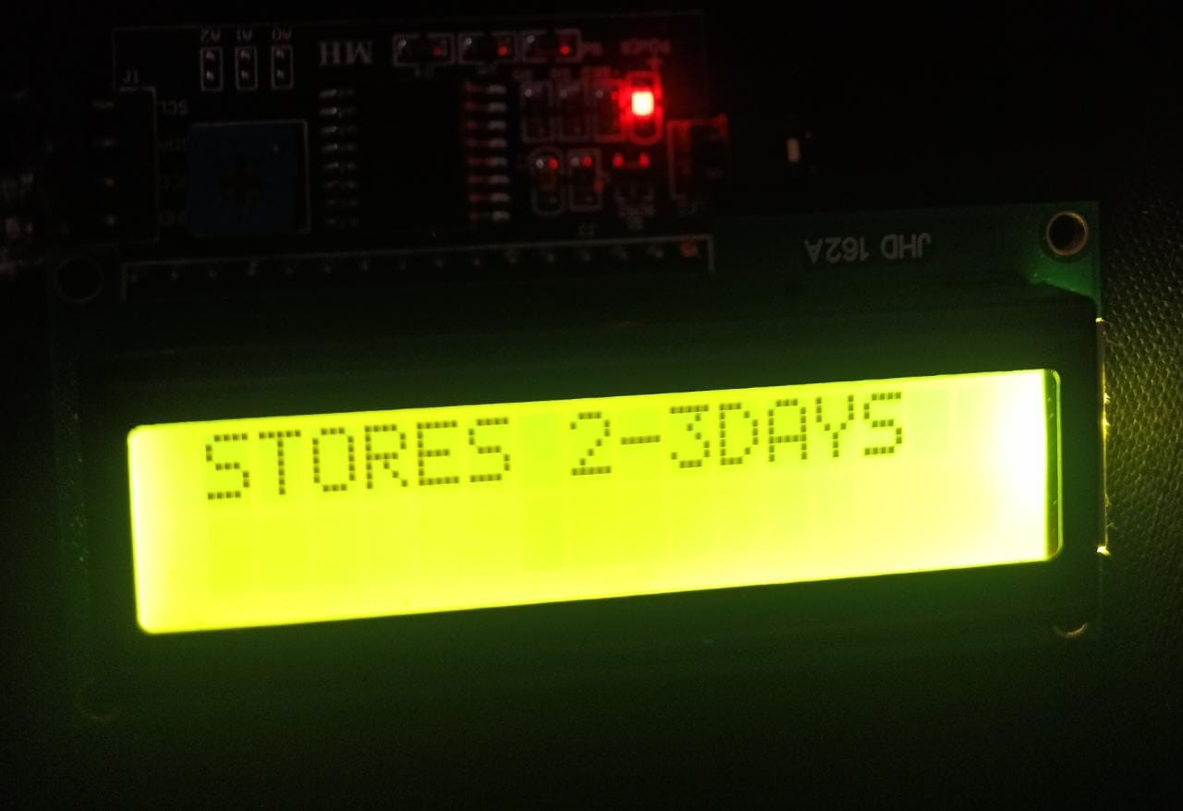
Figure 5.3: Storing days detection of fruit
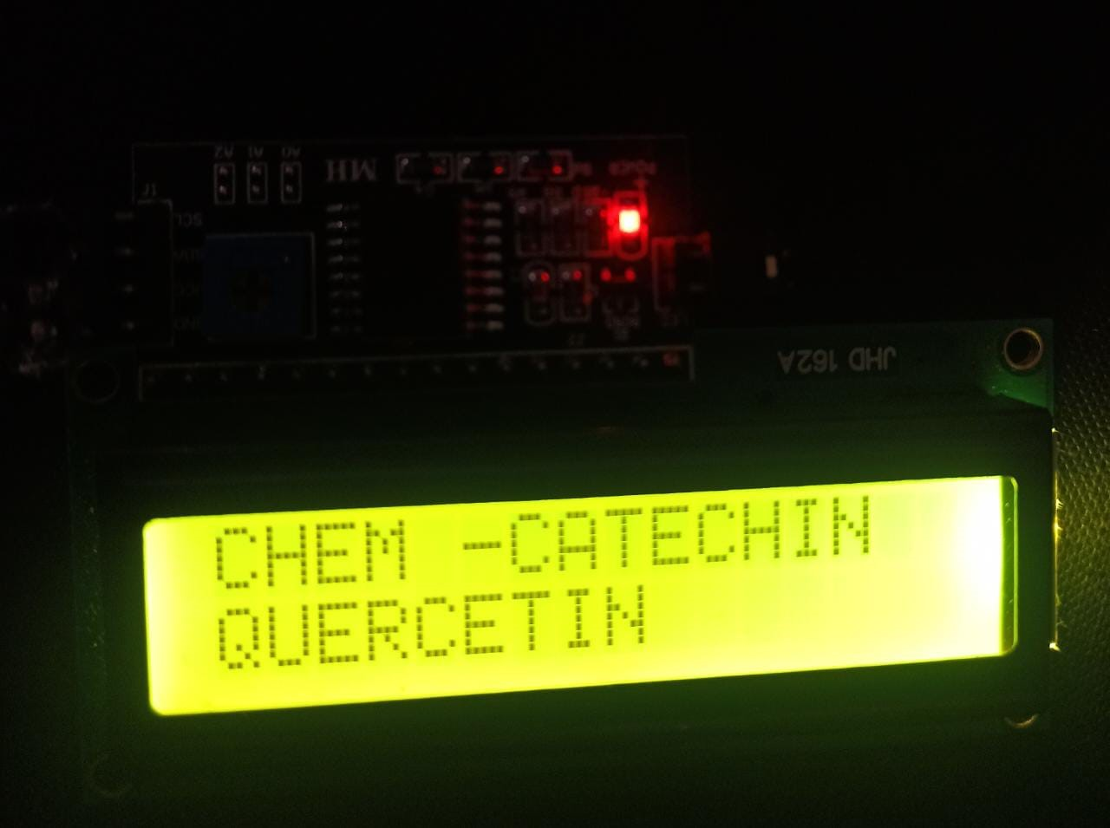
Figure 5.4: Chemical detection in fruit
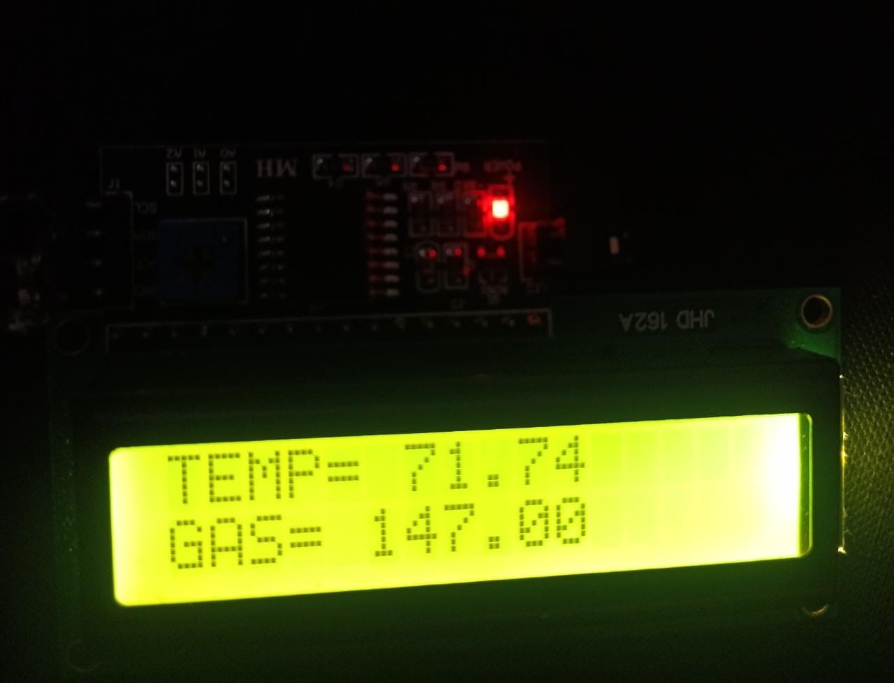
Figure 5.5: Temperature and Gas detection in fruits
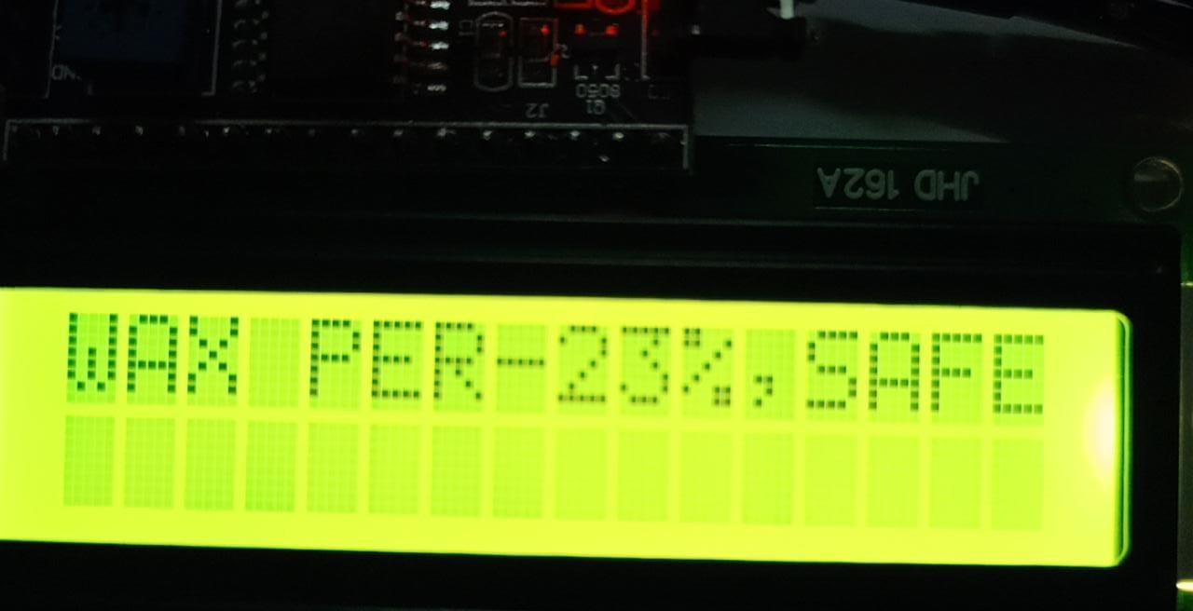
Figure 5.6: Wax Detection
Figure 5.7: fruit detection 2
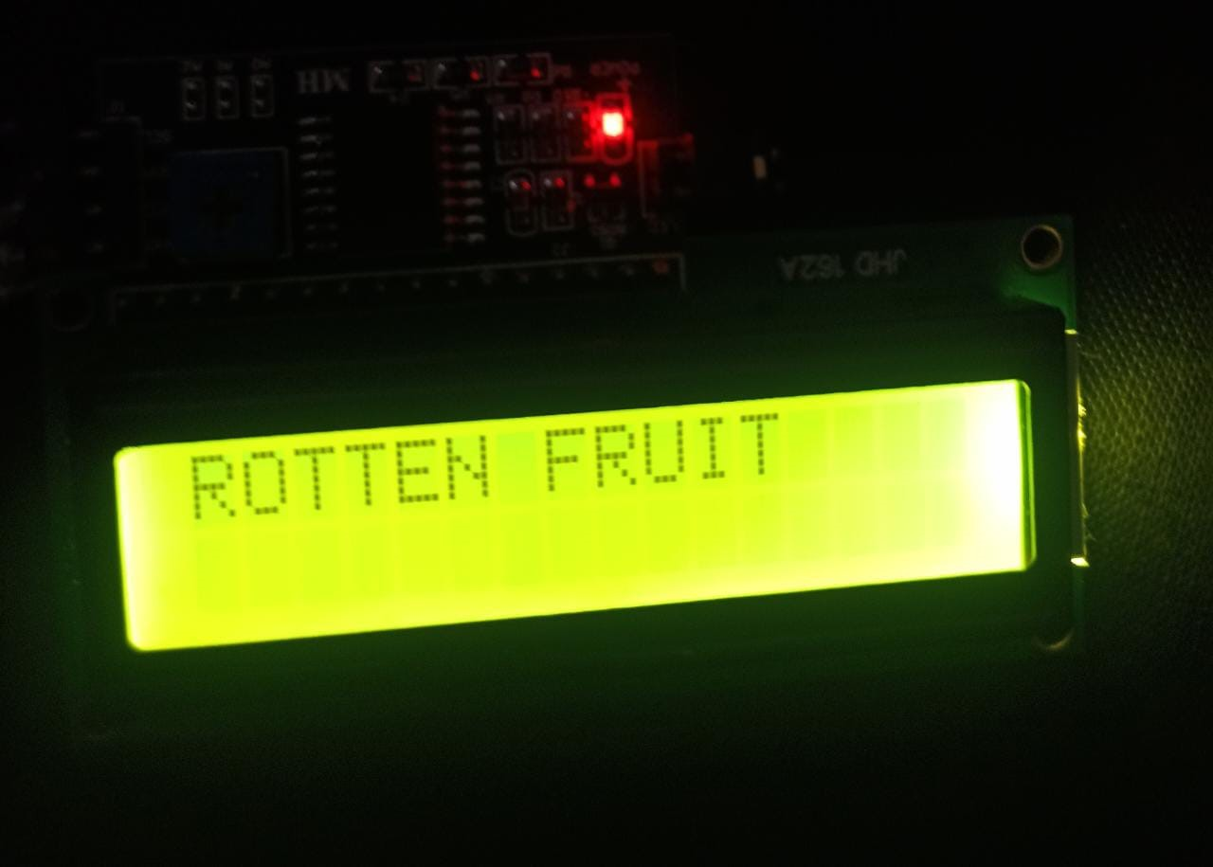
Figure 5.8: Rotten fruit detection
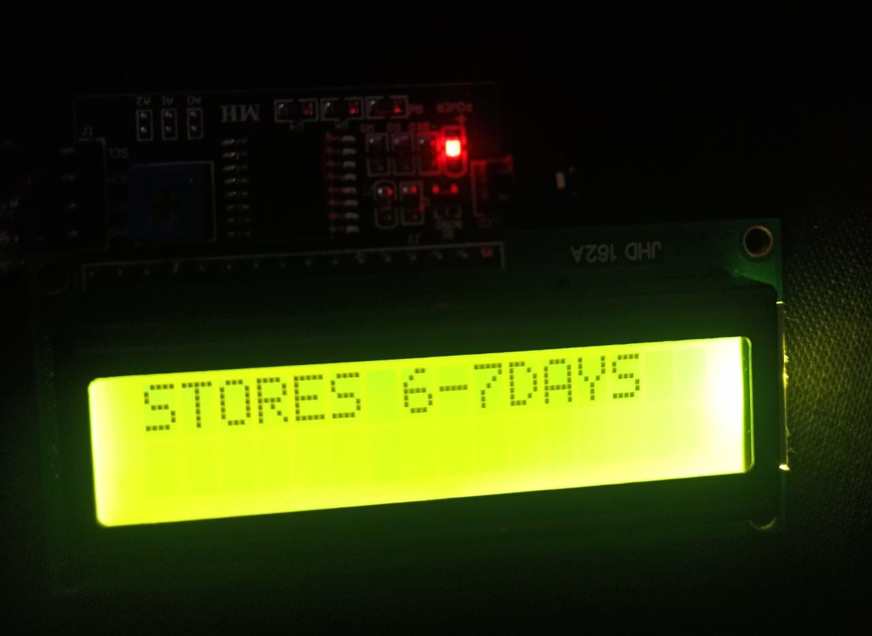
Figure 5.9: Storing Days detection For Fruit CHAPTER 6

CONCLUSION
As a result, this project aims to create a system that controls the freshness and ripeness of the fruit according to its temperature, using the LM35 sensor and a deep learning algorithm. In addition, a method has been proposed to identify fruit as organic or non-organic based on readings from the MQ sensor. The results of this project show that the plan can define the quality of the fruit and provide automated solutions for food quality control and inspection. The planning process will help reduce food waste and improve food quality in the food industry.
In conclusion, this project aimed to develop a system for detecting the freshness and ripeness of fruits based on their temperature using an LM35 sensor and a deep learning algorithm. Additionally, the proposed system aimed to classify fruits as organic or non-organic based on the readings obtained from an MQ sensor. The results of this project showed that the proposed method can accurately detect the quality of fruits, providing an automated solution for food quality control and inspection. The proposed system can potentially contribute to reducing food waste and improving the quality of food products in the food industry.

REFERENCES
[1] Yang, X., Gao, F., & Chen, D. (2019). Application of electronic nose technology in food quality and safety detection. Critical Reviews in Food Science and Nutrition, 59(11), 1753-1773.
[2] Hassan, M. M., Rahman, M. M., & Rahman, M. A. (2019). Electronic nose technology for food quality assessment: A review. Journal of Food Measurement and Characterization, 13(3), 1863-1883.
[3] Xu, L., Li, H., Li, Q., Li, J., Li, Y., & Li, J. (2018). Development of an electronic nose system for detecting apple quality based on colorimetric sensor array and machine learning algorithms. Food Control, 89, 287-293.
[4] Basarir, F., Gökmen, V., & Şahin, S. (2020). Current applications of electronic nose technology in food analysis. Critical Reviews in Food Science and Nutrition, 60(4), 623-638.
[5] Li, Y., Wu, L., Zhao, X., Yang, Z., Zhang, Q., & Wang, X. (2021). A novel electronic nose based on metal oxide sensors for evaluating apple freshness. Postharvest Biology and Technology, 172, 111325.
[6] Xie, L., Li, X., & Wu, D. (2019). Application of electronic nose technology in the detection of fruit and vegetable quality: A review. Food Control, 98, 293-303.
[7] Zhang, Y., Wei, Q., Hu, J., & Cai, R. (2020). A review of electronic nose technology and its applications in food quality and safety detection. Sensors, 20(13), 3713.
[8] Aggelopoulos, T., & Chrysanthou, A. (2020). Electronic nose for food quality analysis. Foods, 9(4), 440.
[9] Peng, J., Wang, Z., Yang, Q., Zhao, J., & Chen, G. (2021). A review on electronic nose applications for food quality assessment. Food Analytical Methods, 14(6), 971-988.
[10] García-Muñoz, R. A., Requena, J., García-Cabezón, C., & Fernández-Escudero, J. A. (2019). Electronic noses in the agri-food industry: A review. Sensors, 19(2), 307.
[11] Gómez, A. H., Bueno, J., & García, J. M. (2021). Use of electronic noses for fruit quality evaluation. In Postharvest Quality Control of Fruits and Vegetables (pp. 187-210). Academic Press.
[12] Leardi, R., & Boggia, R. (2019). Neural networks for electronic nose data analysis in food science: A review. Trends in Food Science & Technology, 93, 143-154.
[13] Li, Y., Li, C., Hu, X., Zhang, Q., & Wang, X. (2020). Research on the electronic nose based on the complementary metal oxide semiconductor gas sensor for detecting the freshness of apple. Journal of Food Science, 85(11), 3824-3834.
[14] Rehman, A., & Mughal, U. R. (2020). Electronic nose-based food quality analysis: A comprehensive review. Journal of Food Processing and Preservation, 44(11), e14943
[15] Sharma, S., & Sinha, A. (2021). Design and Development of Electronic Nose for Food Quality Analysis. International Journal of Control and Automation, 14(4), 113-124. doi: 10.14257/ijca.2021.14.4.11
[16] Kulkarni, P., & Kulkarni, P. (2018). Electronic nose based fruit quality detection: A review. International Journal of Advanced Research in Electrical, Electronics and Instrumentation Engineering, 7(8), 6960-6965. doi: 10.15662/ijareeie.2018.0708015
[17] Yang, Y., Qin, J., Wang, W., & Chen, C. (2020). A review of electronic nose technology for fruit quality evaluation. Food Control, 118, 107405. doi: 10.1016/j.foodcont.2020.107405
[18] Mirabi, M., Bahrami, A., & Ghasemi-Varnamkhasti, M. (2018). Electronic nose applications in fruit industry: A review. Trends in Food Science & Technology, 75, 71-83. doi: 10.1016/j.tifs.2018.03.016
[19] Li, J., Li, X., Li, S., & Chen, J. (2019). Application of electronic nose in food industry: A review. Journal of Food Quality, 2019, 1-14. doi: 10.1155/2019/9654213.
[20] Zhang, Y., Zou, X., Huang, J., & Zhang, L. (2020). Application of electronic nose technology in apple quality detection. Transactions of the Chinese Society of Agricultural Engineering, 36(1), 195-203. doi: 10.11975/j.issn.1002-6819.2020.01.025
[21] Jain, A., & Jain, S. (2021). Review on Electronic Nose and Its Applications in Food Analysis. Trends in Food Science & Technology, 109, 389-405.
[22] Basile, M., Romano, R., & Calabro, G. (2020). Electronic Nose (E-Nose) Technologies for Sensory Analysis in Food Quality Assessment. Journal of Food Science and Technology, 57(1), 1-12.
[23] Capelli, L., Sironi, S., & Del Rosso, R. (2020). An Electronic Nose for Food Quality Control: A Review of Recent Advances. Sensors, 20(18), 1-28.
[24] Jin, L., Wang, Y., & Wang, Y. (2021). Application of Electronic Nose in Apple Quality Detection. Journal of Food Processing and Preservation, 45(10), 1-10.

[25] Khodadadi, M., & Hosseini, M. (2020). Electronic Nose Applications in Food Quality and Safety: A Review. Journal of Food Measurement and Characterization, 14(5), 2495-2510.

[26] Li, H., Liu, J., & Li, X. (2019). Food Quality Analysis with Electronic Nose: A Review. Journal of Food Engineering, 259, 1-14.

[27] Luna, M. A., & Oliveira, L. S. (2021). Electronic Nose for Food Quality Control: A Review. Journal of Food Science and Technology, 58(4), 1299-1311.

[28] Madureira, A. R., Pereira, J., & Nunes, F. M. (2019). Electronic Noses and Tongues in Food Analysis. Comprehensive Reviews in Food Science and Food Safety, 18(6), 1806-1826.

[29] Martins, R. C., Pereira, J., & Rodrigues, L. R. (2020). Electronic Noses in Food Analysis: A Comprehensive Review. Journal of Food Science and Technology, 57(4), 975-987.

[30] Shirsat, M. D., & Waghmare, R. S. (2020). Application of Electronic Nose for Quality Analysis of Fruits and Vegetables: A Review. Journal of Food Science and Technology, 57(8), 2469-2481.

